Russian Federation-UNDP Trust Fund for Development

Template of Project Annual Narrative and Financial Progress Report
(approved by the 6th meeting of the TFD Steering Committee)

25 December 2020

Russian Federation-UNDP Trust Fund for Development (TFD)

Project Annual Narrative and Financial Progress Report
Project title: | Digital skills and opportunities for youth employment towards digital economy in the Kyrgyz Republic
Project ID: | 00114503
Implementing partner: | Ministry of Education of the Kyrgyz Republic
Project budget: | Total: 1,000,000 USD  TFD: 1,000,000 USD
Project start and end date: | February 2019 – June 2021
Period covered in this report: | January – December 2020
Date of the last Project Board meeting: | December 24, 2020
SDGs supported by the project: | Youth and 2030 Agenda: The importance of Youth is recognized in the 2030 Agenda for Sustainable Development and SDGs which set out to ‘substantially increase the number of youth and adults who have relevant skills, including technical and vocational skills, for employment, decent jobs and entrepreneurship’ by 2030 (target 4.4). Over a third of the global 169 SDG targets highlight the role of young people and the importance of their empowerment, participation, and well-being. 20 targets across six SDGs (2, 4, 5, 8, 10, 13, 17) are strongly focused on youth: Zero Hunger, Quality Education, Gender Equality, Decent Work and Economic Growth, Reduced Inequalities, and Climate Action.

1. EXECUTIVE SUMMARY
Kyrgyzstan has a rather young population (median age is 24 years, and people of working age constitute 60% of total population), so the demand for jobs in this age group is high. Women and young people have a higher chance of being unemployed than middle age men. 1/5th of young men chose to seek job opportunities abroad. They mostly occupy relatively low paid work in services (retail, catering, cleaning, utilities etc.) and construction in Russia and other countries. Expert surveys show that the number of citizens of Kyrgyzstan working abroad is over 800,000 people (with 30 % of women migrants).

In 2017 the Government of Kyrgyzstan announced the launch of nation-wide program of digital transformation “Taza Koom” (Smart Nation) that aims to build an open and transparent state, aknowledge-based economy, raise living standards for Kyrgyz citizens, and improve the business environment. Taza Koom conception is a key component of the long-term 2040 National Sustainable Development Strategy which aims to enhance human capital and support innovations in harmony with the environment. The Projects Goal will be to help the Government of Kyrgyzstan to strengthen environment eco-systems protection capacity and advance opportunities for youth and especially young women in a digital economy, support their better integration into the global development community and create sustainable and worthy jobs. Coherent interventions suggested by the Project’s design will lay the groundworks for the following core objectives:

RESULTS:
Component 1: Improved digital skills development in the system of formal education

Activity 1.1: Series of in-depth market studies and consultations with the private sector and experts on the global trends on digital markets, digital jobs and recommendations on required set of skills that will contribute to country’s digital development, with additional focus placed on digital technologies and innovations in the priority sectors of economy

Conducted series of in-depth market research and consultations with the private sector and published on the web in KGZ, RUS, ENG languages.

https://www.kg.undp.org/content/kyrgyzstan/en/home/library/poverty/digital-skills-and-opportunities-for-youth-employment-towards-di.html

https://www.kg.undp.org/content/kyrgyzstan/ru/home/library/poverty/digital-skills-and-opportunities-for-youth-employment-towards-di.html
- https://www.kg.undp.org/content/kyrgyzstan/ky/home/library/poverty/digital-skills-and-opportunities-for-youth-employment-towards-di.html
Prepared Infographics "Digital skills and entrepreneurship":
- https://www.kg.undp.org/content/kyrgyzstan/en/home/presscenter/articles/2020/07/digital-skills-infographics.html
- https://www.kg.undp.org/content/kyrgyzstan/ru/home/presscenter/articles/2020/07/digital-skills-infographics.html
- https://www.kg.undp.org/content/kyrgyzstan/ky/home/presscenter/articles/2020/07/digital-skills-infographics.html

Activity 1.2: Support to formulation of the National Digital Skills Development Strategy (NDSDS) and Roadmap, including identifying current and future digital skills needs and goals, ideally across sectors.
The National Strategy on Digital Skills and Competencies and Roadmap draft developed and sent to MoES and SCITC for review. We will announce after clearance.

Activity 1.3: Upgrading an educational standards and curriculums for building fundamental and emerging digital skills to meet growing demand of the digital economy, including digital inclusion standards for disabled and girls;

The new education standards and curriculums developed with Educational Methodical Body under the Ministry of Education and Science;
Activity 1.4: Introducing and piloting new educational standards and curriculums at the Kyrgyz State Technical University named after I. Razzakov (Bishkek) and Osh Technological University named after M.M Adyshev (Osh) and their subordinated vocational technical colleges and institutions based on agile approach;

- Developed training contents and conducted online trainings for 44 university teachers in new education standards and curriculum;
- For KSTU and OshTU team organized study tour and experience exchange program with joint working group AUCA;
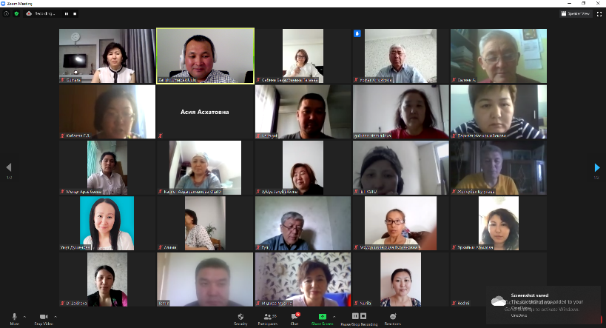
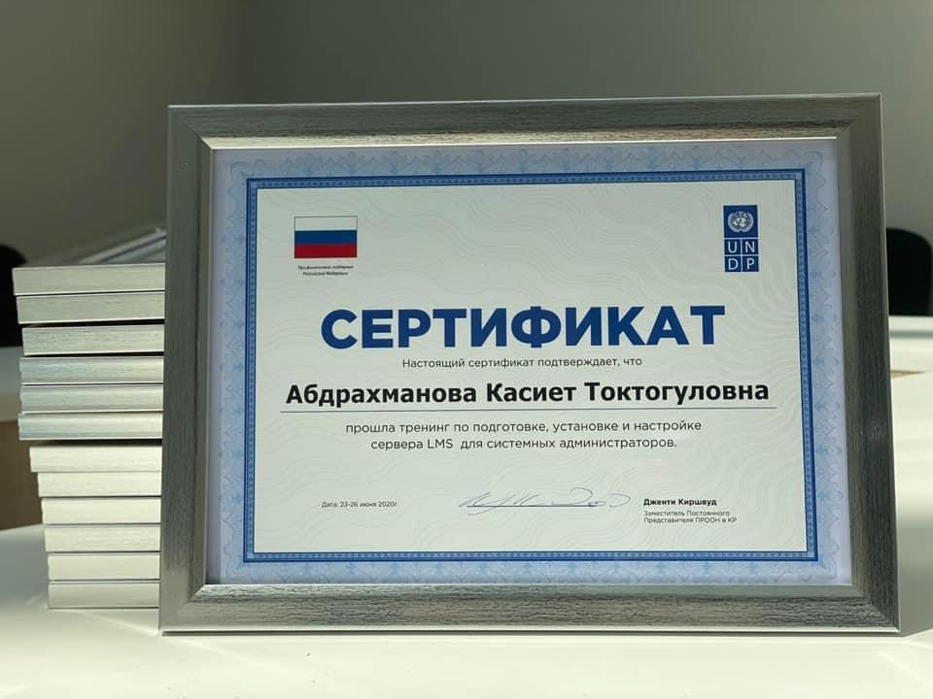
- Supported Career and Practice Day at KSTU for youth with IT companies;

- https://www.facebook.com/116487388447179/posts/3081518201944068/?d=n
- https://twitter.com/undpkg/status/1283997037126725637?s=20
- https://www.facebook.com/116487388447179/posts/3134893546606533/?d=n
- https://www.instagram.com/p/CDgD57OjqPj/?igshid=z5nfb9u7qq2j
- https://www.kg.undp.org/content/kyrgyzstan/ru/home/presscenter/pressreleases/2020/08/undp-supported-dyned---a-new-methodology-for-improving-teachers-.html
- https://www.kg.undp.org/content/kyrgyzstan/ky/home/presscenter/pressreleases/2020/08/undp-supported-dyned---a-new-methodology-for-improving-teachers-.html
- https://www.kg.undp.org/content/kyrgyzstan/en/home/presscenter/pressreleases/2020/08/undp-supported-dyned---a-new-methodology-for-improving-teachers-.html

Activity 1.5: Modernization of equipment and the introduction of new ‘digitalized’ teaching standards at the Kyrgyz State Technical University named after I. Razzakov (Bishkek) and Osh Technological University named after M.M Adyshev (Osh) and their subordinated technical colleges and institutions, including in apparel sector.

- IT infrastructure in the two universities was updated;
- 4 servers delivered and installed 2 for KSTU and 2 for OshTU:
- Installed and configured Windows server 2012 R2 Active Directory, Certification Authority and Network Policy services for user account automation and management;
- Developed training contents on server installation, maintenance, networking systems;
- In October online trainings for 30 university teachers on server usage, maintenance support and installed information systems were held.
- Improved, connected and integrated of existing systems with educational services:
  - Google G-Suite for Education;
  - Microsoft 365 for Education;
  - International education service eduroam.
- KSTU and 2 private universities connected to the Oracle Academy;
- https://www.kg.undp.org/content/kyrgyzstan/en/home/presscenter/articles/2020/12/oracle-comes-to-kyrgyzstan---prospects-and-hopes.html
- https://www.kg.undp.org/content/kyrgyzstan/ky/home/presscenter/articles/2020/12/oracle-comes-to-kyrgyzstan---prospects-and-hopes.html
- https://www.kg.undp.org/content/kyrgyzstan/ru/home/presscenter/pressreleases/2020/12/oracle-comes-to-kyrgyzstan---prospects-and-hopes.html
- https://www.kg.undp.org/content/kyrgyzstan/en/home/presscenter/articles/2020/11/universities-on-line.html
- https://www.kg.undp.org/content/kyrgyzstan/ru/home/presscenter/articles/2020/11/universities-on-line.html
- https://www.kg.undp.org/content/kyrgyzstan/ky/home/presscenter/articles/2020/11/universities-on-line.html

2. RESULTS

Component 2: Established ITHubOsh in Osh City for young entrepreneurs and application of new learning models in non-formal educational settings

Activity 2.1: Contributing to strengthening the infrastructure and institutional capacity of IThubOsh to serve creative space and new generation incubator to foster digital innovations, provide work space, seed funding, access to new financing mechanisms, mentoring support and other support services

- Conceptual document;
- Due to COVID-19 and political instability and unavailability of key Osh city authorities, negotiations were finalized in December;
- Osh city agreed to provide building in the center of the central park;
- It Hub is planned to be implemented through the partnership which involve:
- Youth Committee under the Osh city municipality, State High Technology Park and private firm
- We plan to launch both physical and virtual IT Hub in Osh

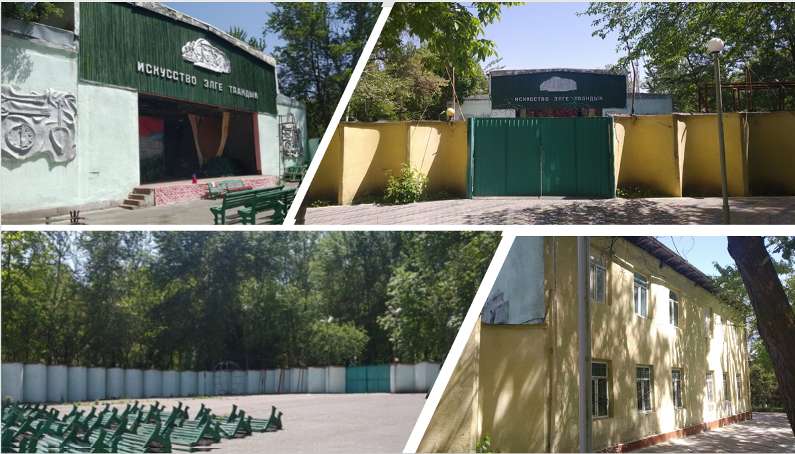

Activity 2.2: Supporting a series of hackathon/hackfest events to engage young computer programmers, interface designers, private sector project managers and subject-matter experts to collaborate on the designing of new business scalable solutions and software products;
More than 48 online webinars, trainings and events conducted with partnership of High Technology Park and ololo. Totally participated more than 11730 people including youth, women, disable people. https://www.facebook.com/HTP.KG/videos/
https://www.facebook.com/hashtag/digitalyouth
Some of topic are as follows:
- E-commerce, cybersecurity, digital resilience, Web Presence, 3-D Modelling, What is StartUp? Cyber Hygiene, Data Science, Develop Mobile Apps, How to build LMS platform? Tools for online courses, Process of creating video-clips, Copyrighting, Graphic design and animation, STAN Agile in Central Asia etc.;
- Women in IT, Why to go to IT?, Why girls should be involved in IT?, Why Java Script? Ideal Programmer etc.;
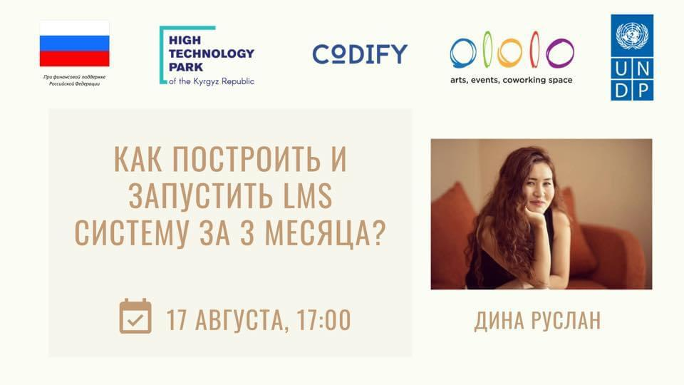
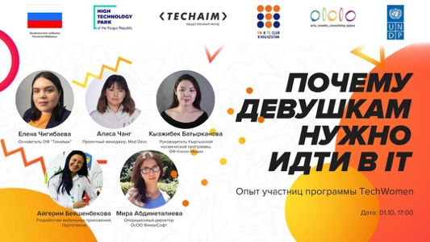
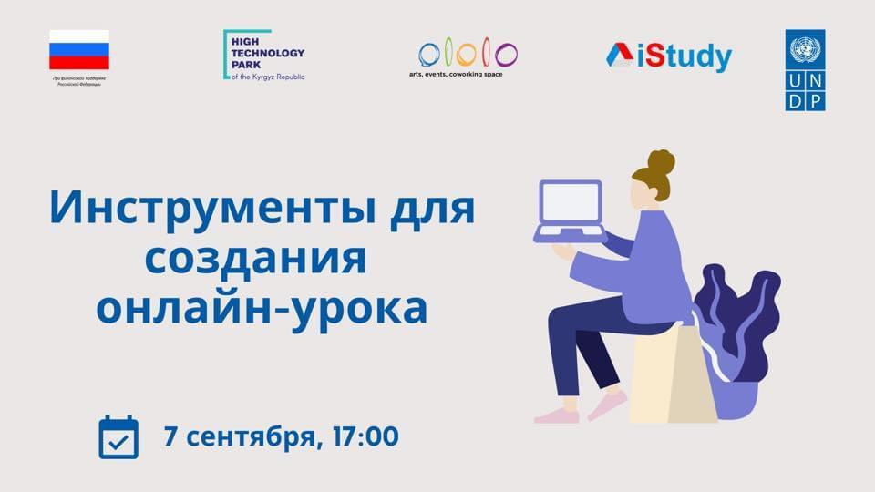
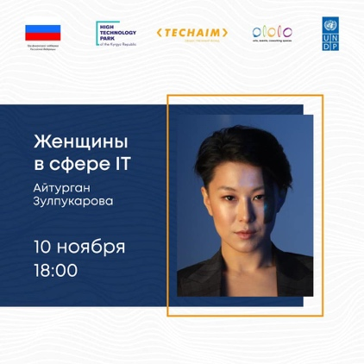
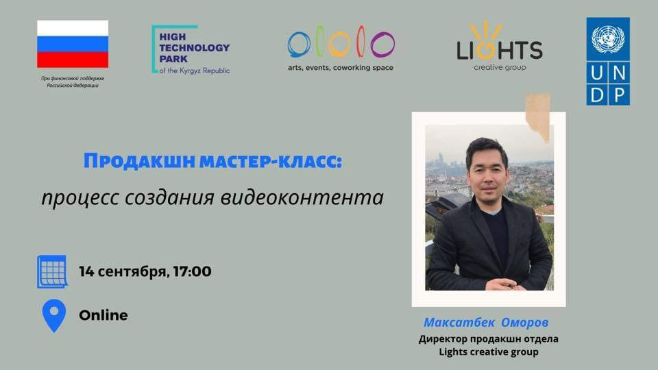
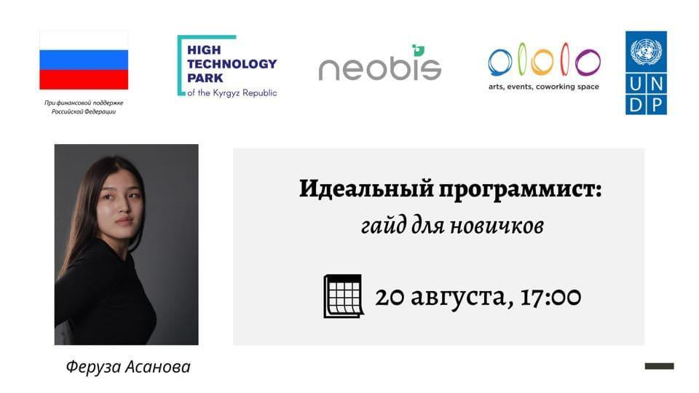

InnoKG Innovation Campaign

Organized Innovation Campaign InnoKg during lockdown, 70 solutions applied and selected 3 solutions:
- Telemedicine project Prime Doc – mobile application "e-patient record";
- Digital learning for deaf kids, digital flash cards and media book for people with hearing impairment;
- Online English courses DyNet – education platform that conducted TOTs for 30 teachers in regions.

InnoKg Challenge Winners: Digital learning for deaf kids, online doctors and English learning platform.
- https://www.kg.undp.org/content/kyrgyzstan/ru/home/presscenter/pressreleases/2020/06/innokg-challenge-winners--digital-learning-for-deaf-kids--online.html
- https://www.kg.undp.org/content/kyrgyzstan/en/home/presscenter/pressreleases/2020/06/innokg-challenge-winners--digital-learning-for-deaf-kids--online.html
- https://www.facebook.com/116487388447179/posts/2986580381437851/?d=n

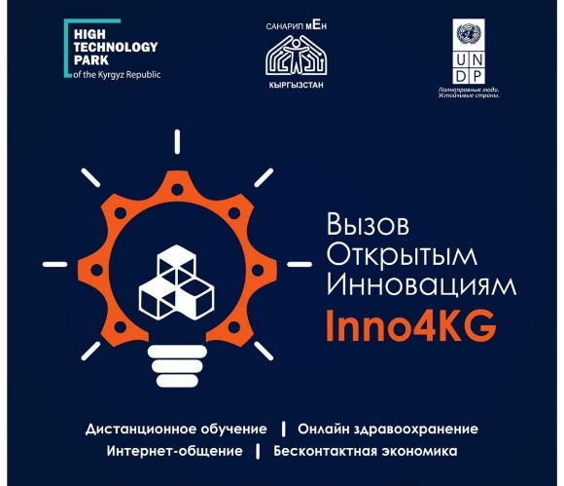

How mobile applications have opened doors for children with hearing loss
- https://www.kg.undp.org/content/kyrgyzstan/en/home/presscenter/articles/2020/12/how-mobile-applications-have-opened-doors-for-children-with-hear.html
- https://www.kg.undp.org/content/kyrgyzstan/ru/home/presscenter/articles/2020/12/how-mobile-applications-have-opened-doors-for-children-with-hear.html
- https://www.kg.undp.org/content/kyrgyzstan/ky/home/presscenter/pressreleases/2020/12/how-mobile-applications-have-opened-doors-for-children-with-hear.html

Digital flash cards and a media book for people with hearing impairment. Another solution from Inno KG Challenge
- https://www.facebook.com/116487388447179/posts/3073811882714700/?d=n
- https://www.kg.undp.org/content/kyrgyzstan/en/home/presscenter/articles/2020/07/innovation-call-winners.html
- https://www.kg.undp.org/content/kyrgyzstan/ru/home/presscenter/articles/2020/07/innovation-call-winners.html
- https://www.kg.undp.org/content/kyrgyzstan/ky/home/presscenter/articles/2020/07/innovation-call-winners.html

e-hackathon
Jointly with UNICEF organized e-hackathon during pandemic, applied 60 digital solutions and supported 3 solutions:
- ClickHelp Bot – helps women and young people to recognize signs of domestic violence and will also link them to nearby crisis centers and psychologists.;
- Smart Jomok – web service that helps psychologists, teachers, educators and parents to get to know their children better through fairy tales;
- Burulay Project – provide solutions to prevent domestic violence on a digital platform.

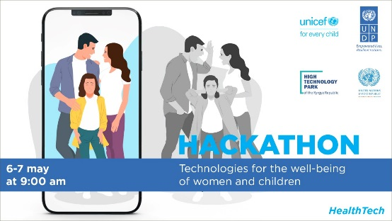
E-hackathon participant: "I've been friends with E-technology since I was 5»

- https://www.kg.undp.org/content/kyrgyzstan/ru/home/presscenter/articles/2020/05/e-hackathon-participant---i-ve-been-friends-with-e-technology-si.html?fbclid=IwAR21yKze52WlbbmhoJG_JV3Hmwhud6gL9GNytIjeFSp4Z0-z3OASAZymgDo
- https://www.kg.undp.org/content/kyrgyzstan/en/home/presscenter/articles/2020/05/e-hackathon-participant---i-ve-been-friends-with-e-technology-si.html
- https://www.facebook.com/116487388447179/posts/2895745830521307/?d=n
- https://twitter.com/undpkg/status/1257593547731189760?s=20
History of IT programmers, hackathon participants - Tilek Egemberdiev and Daniila Kolodyazhnogo
- https://www.facebook.com/116487388447179/posts/2897770400318850/?d=n
- https://twitter.com/undpkg/status/1257925303307026433?s=20
IT solutions developed by young people will help end domestic violence against women and children
Post-release on Hakaton, article in BAYAN magazine
- https://www.kg.undp.org/content/kyrgyzstan/ru/home/presscenter/pressreleases/2020/05/it-solutions-developed-by-youth-will-help-to-cope-with-domestic-.html
- https://www.kg.undp.org/content/kyrgyzstan/ky/home/presscenter/pressreleases/2020/05/it-solutions-developed-by-youth-will-help-to-cope-with-domestic-.html
- https://www.kg.undp.org/content/kyrgyzstan/en/home/presscenter/pressreleases/2020/05/it-solutions-developed-by-youth-will-help-to-cope-with-domestic-.html
- https://www.facebook.com/116487388447179/posts/2911830908912799/?d=n
- https://twitter.com/undpkg/status/1260126254973489152?s=20

COURSERA Courses for Kyrgyzstan
The High Technologies Park with assistance from the SCITC and UNDP announced a competition for a free online training program on Coursera.
More than 4,000 Kyrgyz citizens are now studying on the Coursera educational platform;
Below are the TOP 10 most popular courses among Kyrgyz people.
1) Programming for all (Getting started with Python)
2) Writing professional emails in English
3) Professional English
4) Technical support (Basics)
5) Basics of programming with JavaScript, HTML and CSS
6) Grammar and punctuation (English language)
7) Course on Python
8) Work on essays (English language)
9) Business letter (English-language)
10) Introduction to psychology

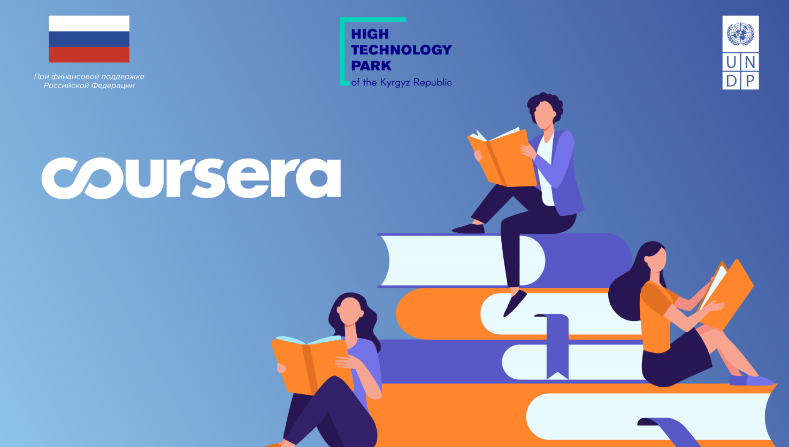

- https://www.kg.undp.org/content/kyrgyzstan/en/home/presscenter/pressreleases/2020/12/top-10-courses-kyrgyzstan.html
- https://www.kg.undp.org/content/kyrgyzstan/ru/home/presscenter/articles/2020/12/top-10-courses-kyrgyzstan.html
- https://www.facebook.com/116487388447179/posts/3478954502200434/?d=n
- https://www.instagram.com/p/CISsWY8MBU3/?igshid=5aq477qx5d7q

Activity 2.3: Facilitating intensive knowledge exchange and master classes that will engage digital-savvy experts from Skolkovo, Kazan Techno Park and other global creative spaces to bring advice and tips for starting a digital business and establishing business models for scaling business-lead technology solutions;
Developed report on “Comparative analysis of e-commerce development in Russian Federation and the Kyrgyz Republic with recommendations for Kyrgyzstan” and conducted following webinars:
- Webinar 1: Electronic Commerce. Niche selection and direction determination. Required tools and skills;
- Webinar 2: Building Business Processes in E-Commerce;
- Webinar 3: Working with platforms, own online stores;
- Webinar 4: Developing Quality Content and Ecommerce Promotion Channels

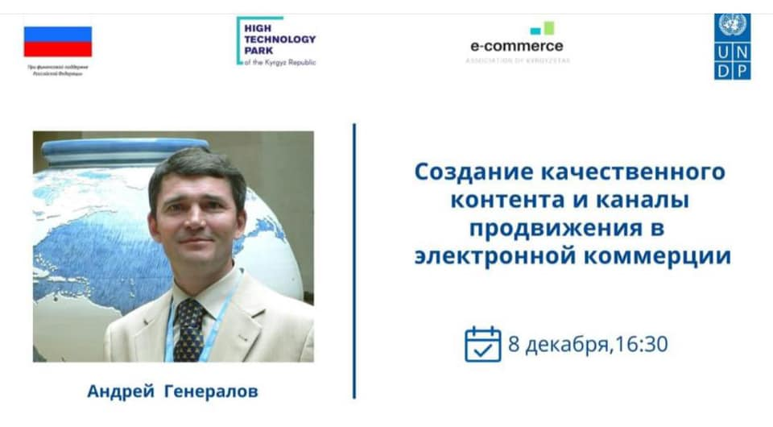
- https://www.facebook.com/undpkg/posts/3482009291894955
- https://www.instagram.com/p/CIVgv-8s233/?igshid=10qbudpp7ms2d

Activity 2.4: Carrying out targeted country-wide awareness-raising campaigns for identified target underprivileged groups, with focus on rural girls, young women and youth with special needs, to inform about benefits of digital technologies and digital skills, and to encourage the use of digital services;

- Developed 12 short video films on digital champions to promote digital entrepreneurship and digital economy among youth;
- Developed DigiKyzdar short video about successful girls in IT;
- Developed 30 mins “Jyldyz” film about digital skills and competencies benefits.
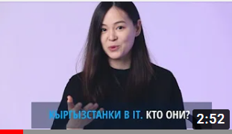
- All videos are shown in Prime-Time television broadcast of Kyrgyz Television Radio Company http://ktrk.kg/ (90% population covered) and placed in YouTube channels.

Activity 2.5: Establishing closer contacts and exchange of information between public and private sector and between industry and education to address skills mismatch. Encourage and facilitate digital skills internships in the companies;

Developed and published report on “Establishing closer contacts and exchange of information between public and private sector and between industry and education to address digital skills mismatch” with recommendations of the MOE, SCITC, Business Associations, Universities, Banks, NGOs
Almaz Beishenaliev, local expert. Current Minister of Education and Science;
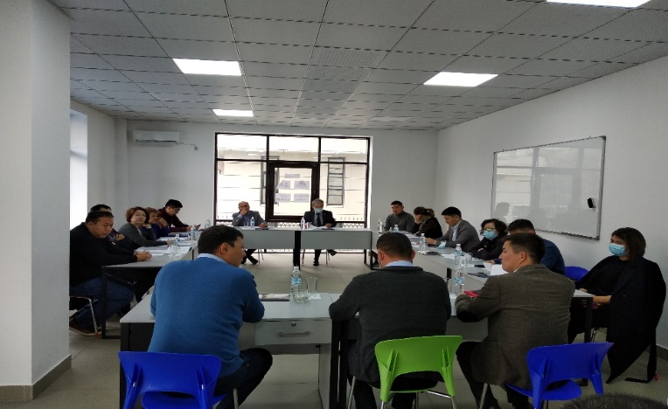

Activity 2.6: Capacity building of new generation of IT teachers and raising awareness of new learning methods, including designing and prototyping new learning products for girls and youth with special needs
Republican Institute for Advanced Studies and Retraining of Pedagogical Workers under Ministry of Education and Science of the Kyrgyz Republic

- Improved, connected and integrated of existing systems with educational services:
Google G-Suite for Education;
Microsoft 365 for Education;
International education service eduroam.
- Installed and configured LMS platform https://ec.ripk.kg/, Windows server, Network services for user account automation and management;
- Developed online training contents on:
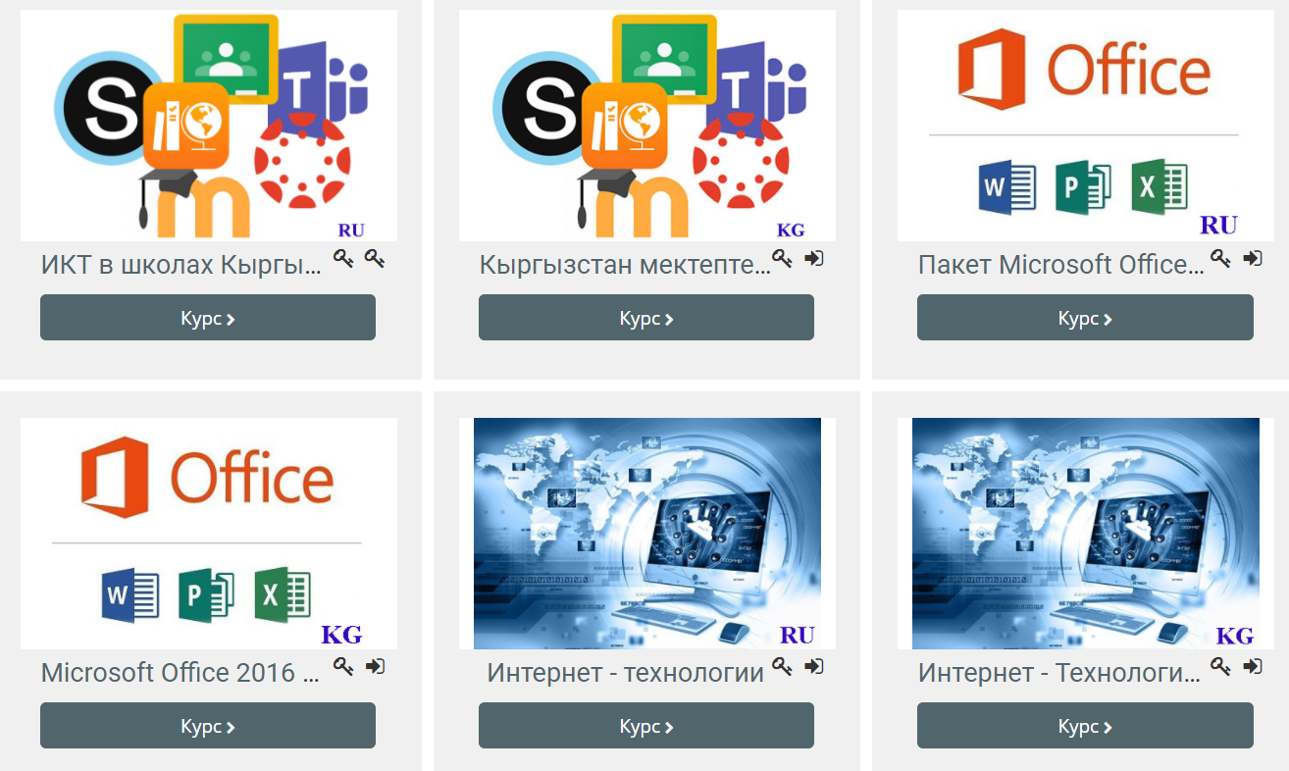
ICT in schools, MS Office, Internet, Power Point, Google Service, Smart Panel, Distance Learning Technologies, SCORM;
- Conducted online 72 hours TOTs for 198 schoolteachers on developed contents with all Advanced Studies and Retraining requirements

Nation level research documents/reports in KGZ, RUS, ENG languages that are published:
- "Digital skills and entrepreneurship” – Aziz Soltobaev, local expert;
- “Comparative analysis of e-commerce development in Russian Federation and the Kyrgyz Republic with recommendations for Kyrgyzstan” – Andrey Generalov, international expert from Skolkovo;
- “Digital Skills for Digital Economy” – Gulnara Djunushalieva, international consultant;
- “Establishing closer contacts and exchange of information between public and private sector and between industry and education to address digital skills mismatch” – Almaz Beishenaliev, local expert. Current Minister of Education and Science;
- “National Strategy on Digital Skills and Competencies” - Aziz Soltobaev, local expert

Support SCITC on Information Campaign of Sanarip Kyrgyzstan and COVID activities
- President S. Jeenbekov familiarized himself with the use of digital technologies in the fight against coronavirus;
- Created an emergency IT headquarters to support the fight against the spread of coronavirus infection and its consequences, where more than 400 IT programmers developed digital solutions;
- Developed video film on using state web portal Covid.kg;
- Presentation of innovative iGOV products;
- Digital dialogue of the President of the Kyrgyz Republic with regional leaders;
- Press briefing on the work of the SCITC, IT headquarters as part of the work of the Republican headquarters to fight against the coronavirus;
- completed 100 communications - news feeds;
- 55 publications posted on key initiatives of the SCITC;
- Prepared and posted 40 posts on the website and in the social networks, conducted 10 targeted advertising campaigns;
- Developed 5 infographics on Digital Transformation and Digital Economy events

Results on indicators

EXPECTED OUTPUTS | OUTPUT INDICATORS | planned | Result
 |  | 2020 | 2020
Output 1: Improved digital skills development in the system of formal education | 1.1 Approval of the National Digital Skills Development Strategy | NDSDS developed | NDSDS developed sent to review of MES
 | 1.2 # of students participated at the new training programmes | 1-2 new education standard | 3 new education standards developed
 | 1.3 % of girls participated at the new training programmes | 20% | In 2021
 | 1.3 # of teachers with increased capacity on new digital skills development | 60 | 88 university teachers
 | 1.4 # of students employed after graduation | 500 | after 4 years graduation
Output 2: Established ITHubOsh in Osh City for young entrepreneurs and application of new learning models in non-formal educational settings | 2.1 Fully operational IT hub in Osh province with # of full-time residents | 30 | in 2021 after renovation
 | 2.2 # of participants of hackathon events | 1000 | participated 11730
 | 2.3 # of youth trained at IThubOsh | 1200 | trained  11730+4000 youth
 | 2.4 % of girls participated in the IT courses | 50% | 50% participated
 | 2.5 # of teachers trained at IThubOsh | 75 | 198 teachers trained
 | 2.6 % of youth employed after graduation | 20% | in process

Budget Structure and proposed extension
Components | Budget, USD $
 | Approved | Planned | Extension for 6 months
 | 2020 | 2021 | 2021
Output 1: Improved digital skills development in the system of formal education | 324 055 | 216 000 | to allocate for PM expenses = 16 236 USD
Output 2: Established IT Hub in Osh City for young entrepreneurs and application of new learning models in non-formal educational settings | 421 488 | 223 560 | to allocate for PM expenses = 16 236 USD
Project management, M&E | 69 419 | 56 666 | PM expenses for the extension = 32 472 USD
GMS | 60 367 | 33 545
TOTAL: | 814 963 | 496 226

3. PROJECT RISKS

The project monitoring and evaluation indicators planned for achievement in the project document are somewhat overstated and not adequate to the available financial resources. In this regard, it is necessary to revise some indicators and make appropriate changes after consultation with the donor and members of the project management board. There are some concrete indicators should be revised and informed to donors in last Project Board meeting.

For example:

1.4 # of students employed after graduation – this means that only after minimum bachelor’s degree 4 years graduation, we can see the real result;

4. LESSONS LEARNT

When planning similar projects in the future, it is recommended to conduct in-depth studies with closer and regular consultations with national partners from government and business both at the central and local levels. Market research should be conducted at the initial stage of the project to obtain important baseline indicators. It is important to choose the main national partner who is extremely interested in the final results of the project and has strong partnerships with other actors in the development process, especially from the private sector.

Highly recommended not to write concrete private company as a partner that working/selecting private companies in ProDoc should be through open tender.

5. FUTURE PLANS

Component 1.
There are three main tasks:
- Develop and conduct TOTs for two universities (KSTU and OshTU) teachers new training contents in new subjects;
- Develop video classes on new subjects for students;
- Launch accelerator labs based in two universities KSTU and OshTU;
- Mentorship training programs be conducted with residents of the High Technology Park for KSTU and OshTU students in entrepreneurships.

Component 2.

There are following main tasks:
- Renovate the selected building in Osh for IT Hub in Osh;
- Negotiate with potential partner implementer of the IT hub Osh;
- Start to conduct online trainings in e-entrepreneurships;
- Conduct webinar with experts from Skolkovo.

6. PARTNERSHIPS
Component 1:
Main partners are the Ministry of Education, SCITC, Osh Mayor City, KSTU, OshTU, private sector.

Component 2:
High Technology Park, private companies other stakeholders.

7. PARTNERSHIP WITH THE RUSSIAN FEDERATION
Cooperation with Russian institutions.
For the first component both pilot KSTU and OshTU are the members of Unions of Universities in CIS countries where the leading Russian universities are working with. To develop and conduct TOT for university staff and improvements of education level and new subjects.

Use of Russian expertise.

To conduct an intensive exchange of knowledge and master classes, it is necessary to attract experienced specialists in the field of digital technologies from Skolkovo, Kazan Technopark and other world creative spaces, to transfer know-how and to start a digital business and create new business models for scaling successful business technology solutions tested in the Russian Federation.

8. COMMUNICATION AND VISIBILITY
№ | Name | Product | Link
1 | Joint development of illustration with HTP and Ololo. Promotion on UNDP channels. | How to build an LMS system in three months? Webinar. | https://www.facebook.com/116487388447179/posts/3157392581023296/?extid=0&d=n  https://www.instagram.com/p/CD0jqATj3zN/?igshid=v11zvkv2og2b
2 | Joint development of illustration with HTP and Ololo. Promotion on UNDP channels. | Basics of IT. Instruction for beginners. Webinar. | https://www.facebook.com/116487388447179/posts/3168641536565067/?extid=0&d=n  https://www.instagram.com/p/CD-alvDD-R6/?igshid=ifim61ejgk2t
3 | Placing Capital’s video on the UNDP social networks + description | In this publication you will see a Timur Mone who founded a real estate company with its head office in New York. | https://www.facebook.com/116487388447179/posts/3175041212591766/?extid=0&d=n  https://www.youtube.com/watch?v=hrWOZyec3ZI&list=PLOu-CsdLaS7Q6qj88aLZxUhwcTlJUPix5
4 | Joint development of illustration with HTP and Ololo. Promotion on UNDP channels. | Tools for creating online-lesson. Webinar. | https://www.facebook.com/116487388447179/posts/3216865505076003/?extid=0&d=n  https://www.instagram.com/p/CEnoyaQjbf7/?igshid=13xg9zu9lmhgs
5 | Placing Capital’s video on the UNDP social networks + description | "Analysis and continuous self-development". Bermet Koshoeva shared the secrets of successful e-trade at Amazon. | https://www.facebook.com/116487388447179/posts/3220394831389737/?extid=0&d=n  https://www.youtube.com/watch?v=9Fr4YNOrwKc&list=PLOu-CsdLaS7Q6qj88aLZxUhwcTlJUPix5&index=3
6 | Placing video on the UNDP social networks | A video about the COVID-19, so that people can read reliable sources. | https://www.facebook.com/116487388447179/posts/3232291530200067/?vh=e&extid=0&d=n
7 | Joint development of illustration with HTP and Ololo. Promotion on UNDP channels. | Women in IT. Webinar.  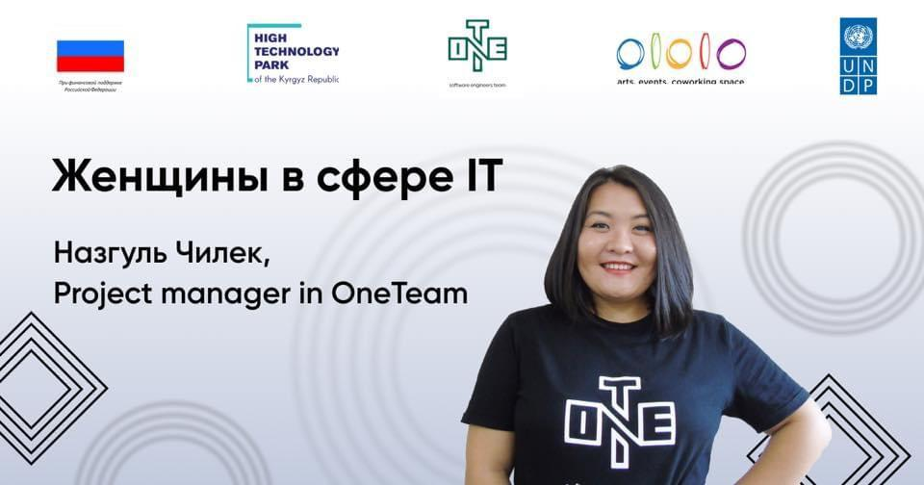 | https://www.facebook.com/116487388447179/posts/3239332946162592/?extid=0&d=n  https://www.instagram.com/p/CE6XE29Dhvk/?igshid=1u3nb1cpefcnb
8 | Joint development of illustration with HTP and Ololo. Promotion on UNDP channels. | Process of creating video-clips. Webinar. | https://www.facebook.com/116487388447179/posts/3242679999161220/?extid=0&d=n  https://www.instagram.com/p/CE9J70jDZwY/?igshid=1hhy6k789c80y
9 | Placing Capital’s video on the UNDP social networks + description | Accidentally take a free IT course and become a developer...  Story of Meerim Aitikeeva | https://www.facebook.com/116487388447179/posts/3254408751321678/?extid=0&d=n  https://www.youtube.com/watch?v=w4giLJxPXG0
10 | Article about free courses for Kyrgyz citizens | HTP and SCITC with UNDP support will provide free courses at Coursera for Kyrgyz citizens.  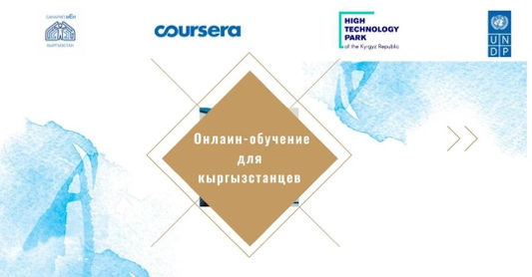 | https://www.kg.undp.org/content/kyrgyzstan/en/home/presscenter/pressreleases/2020/09/htp-and-state-committee-on-information-and-communication-technol.html  https://www.kg.undp.org/content/kyrgyzstan/ru/home/presscenter/pressreleases/2020/09/htp-and-state-committee-on-information-and-communication-technol.html  https://www.kg.undp.org/content/kyrgyzstan/ky/home/presscenter/pressreleases/2020/09/htp-and-state-committee-on-information-and-communication-technol.html  https://www.facebook.com/116487388447179/posts/3260927614003125/?extid=0&d=n
11 | Joint development of illustration with HTP and Ololo. Promotion on UNDP channels. | Why girls should be involved in IT sector. | https://www.facebook.com/116487388447179/posts/3300545246708028/?extid=0&d=n  https://www.instagram.com/p/CFt2zq1DS5E/?igshid=pdqx94eleh0p
12 | August 2020  Joint development of illustration with HTP and Ololo.  Promotion on UNDP channles. | Creation of a mobile application on Android. Master class.  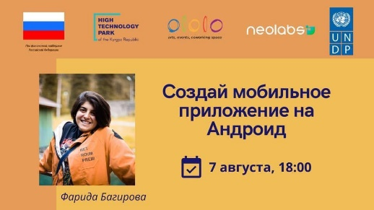 | https://www.facebook.com/116487388447179/posts/3114643121964909/?d=n  https://www.instagram.com/p/CDNg0whjzOT/?igshid=k0u7ur9c07jp
13 | Coordination of developing infographics.  Promotion on UNDP channels. | Infographics "Digital skills and entrepreneurship".  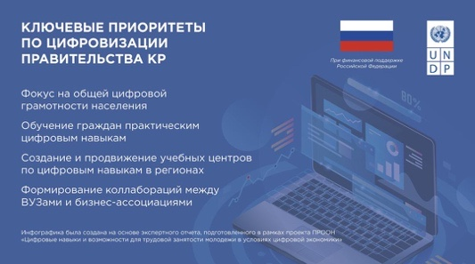  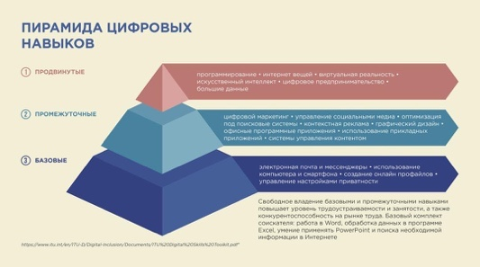 | https://www.kg.undp.org/content/kyrgyzstan/ru/home/presscenter/articles/2020/07/digital-skills-infographics.html  https://www.kg.undp.org/content/kyrgyzstan/ky/home/presscenter/articles/2020/07/digital-skills-infographics.html  https://www.kg.undp.org/content/kyrgyzstan/en/home/presscenter/articles/2020/07/digital-skills-infographics.html  https://www.facebook.com/116487388447179/posts/3098582173571004/?d=n  https://www.instagram.com/p/CC-zorUDekO/?igshid=m7in6hzv6qpi  https://twitter.com/undpkg/status/1286265826857951233?s=21
14 | July 2020  Joint development of illustration with HTP and Ololo. Promotion on UNDP channles. | How to continue learning during the Coronavirus era. | https://www.facebook.com/116487388447179/posts/3095747377187817/?d=n  https://www.instagram.com/p/CC8OhomDqAc/?igshid=m4800rv04m8n
15 | July 2020  Inno competition. Article. | A new methodology for improving teachers’ skills. About the winners of the Inno KG. | https://www.kg.undp.org/content/kyrgyzstan/en/home/presscenter/articles/2020/07/improving-teacher-skills-innovation-call.html  https://www.kg.undp.org/content/kyrgyzstan/ru/home/presscenter/articles/2020/07/improving-teacher-skills-innovation-call.html  https://www.kg.undp.org/content/kyrgyzstan/ky/home/presscenter/articles/2020/07/improving-teacher-skills-innovation-call.html  https://www.facebook.com/116487388447179/posts/3090047821091106/?d=n
16 | July 2020  Award ceremony for teachers | 44 trainers have improved their knowledge in preparing personnel for IT areas | https://www.facebook.com/116487388447179/posts/3081518201944068/?d=n  https://twitter.com/undpkg/status/1283997037126725637?s=20
17 | July 2020  Organisation of interview on radio Sputnik Kyrgzystan | How does a number help young people make money in the Coronavirus era? | https://www.facebook.com/116487388447179/posts/3076558745773347/?d=n  https://m.ru.sputnik.kg/osobyj-akcent/20200715/1049015360/proekt-cifrovizaciya-obuchenie-prooon-kyrgyzstan-student-zarabotok-prepodavatel.html?mobile_return=no
18 | July 2020  Joint development of illustration with HTP and Ololo.  Promotion on UNDP channles. | Introduction to Data Science. Webinar.  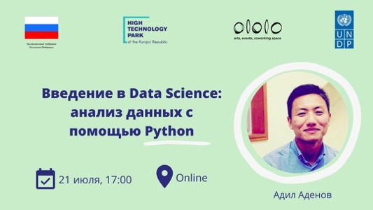 | https://www.facebook.com/116487388447179/posts/3074244372671451/?d=n  https://www.instagram.com/p/CCpZgdHDpKb/?igshid=15nsj02x3flf
19 | July 2020  Innovative competition. Article. | Digital flash cards and a media book for people with hearing impairment. Another solution from Inno KG Challenge. | https://www.facebook.com/116487388447179/posts/3073811882714700/?d=n  https://www.kg.undp.org/content/kyrgyzstan/en/home/presscenter/articles/2020/07/innovation-call-winners.html  https://www.kg.undp.org/content/kyrgyzstan/ru/home/presscenter/articles/2020/07/innovation-call-winners.html  https://www.kg.undp.org/content/kyrgyzstan/ky/home/presscenter/articles/2020/07/innovation-call-winners.html
20 | July 2020  Joint development of illustration with HTP and Ololo. Promotion on UNDP channles. | Start-up B12. Story of success of Murat Dzhumashev.  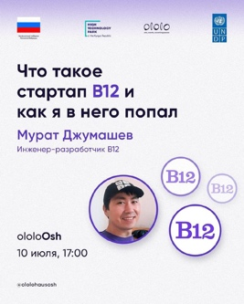 | https://www.facebook.com/116487388447179/posts/3054655847963637/?d=n  https://www.instagram.com/p/CCVix2iD9FR/?igshid=pur6h9df4tlk
21 | July 2020  Joint development of illustration with HTP and Ololo. Promotion on UNDP channels. | Why JavaScript is perfect language in IT? | https://www.facebook.com/116487388447179/posts/3034012016694687/?d=n  https://www.instagram.com/p/CCAc-KBj7Ht/?igshid=16u914kujq91u
22 | June 2020.  COVID-19 response publication. | How does a COVID-19 infection create a huge technological challenge? | https://www.facebook.com/notes/undp-in-the-kyrgyz-republic/как-инфекция-covid-19-создает-огромный-технологический-вызов/3015085485254007/?av=116487388447179&eav=Afbm0Ipvma3Amxj6OheeYYVvy5QTlJJbAwmomclah5SGam8eBfxdVvT7FTKTPIJeY_M
23 | June 2020  Training for teachers. | Seminar on advanced training of teachers of Razakov University and OshTU. | https://www.facebook.com/notes/undp-in-the-kyrgyz-republic/е-семинар-по-повышению-квалификации-преподавателей/3003761099719779
24 | June 2020.  Innovation contest. Solutions. Article. | InnoKg Challenge Winners: Digital learning for deaf kids, online doctors and English learning platform.  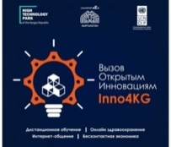 | https://www.kg.undp.org/content/kyrgyzstan/ru/home/presscenter/pressreleases/2020/06/innokg-challenge-winners--digital-learning-for-deaf-kids--online.html  https://www.kg.undp.org/content/kyrgyzstan/en/home/presscenter/pressreleases/2020/06/innokg-challenge-winners--digital-learning-for-deaf-kids--online.html  https://www.facebook.com/116487388447179/posts/2986580381437851/?d=n
25 | March 4-5  Meeting of the working group with the pilot universities (KSTU and OshTU) | Note: "Electronic citizen" who is this and who will become? "  42 photos, coverage of the event in social networks. | http://bit.do/fy2km  https://twitter.com/undpkg/status/1235480264522022923?s=20  https://twitter.com/undpkg/status/1235495603330854912?s=20  https://twitter.com/undpkg/status/1235780774739300352?s=20  https://twitter.com/undpkg/status/1235782149317554177?s=20
26 | 13-February 2020  Career Fair | Note: "UNDP supported the day of career and practice at KSTU named after Razzakov", 6 photos, coverage in social networks. | http://bit.do/fy2i5  https://flickr.com/photos/undpkg/albums/72157713099997001
27 | 13-February 2020  Meeting with cybersecurity expert M. Hathaway | «Cyberattacks on business: Is it real for Kyrgyzstan?»  11 photos,  social media coverage of the event. | https://www.kg.undp.org/content/kyrgyzstan/en/home/presscenter/articles/2020/03/no-country-in-the-world-can-solve-the-problem-of-cybersecurity-o.html  https://www.kg.undp.org/content/kyrgyzstan/ru/home/presscenter/articles/2020/03/no-country-in-the-world-can-solve-the-problem-of-cybersecurity-o.html  http://bit.do/fy2ho  https://flickr.com/photos/undpkg/albums/72157713076639777
28 | August 2020  Post-release on ceremony of awarding certificates.  Organizing event with Jenty Kirsch-Wood.  Developing and coordinating certificates.  Posting in social media. | Ceremony of awarding certificates to teachers. Teachers of English learned a new innovative teaching method as part of an innovative contest.  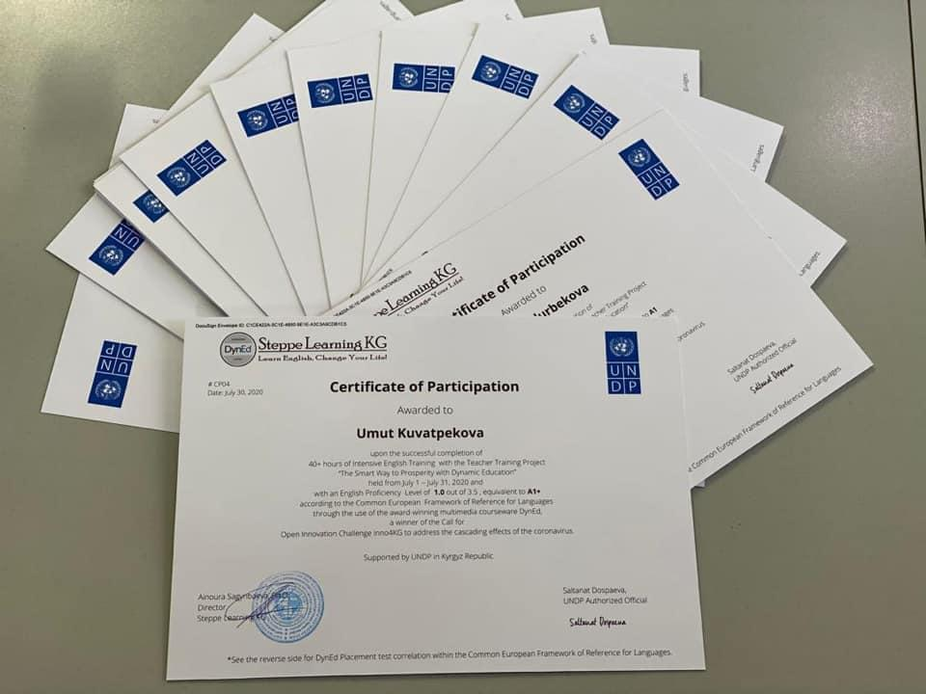 | https://www.facebook.com/116487388447179/posts/3134893546606533/?d=n  https://www.instagram.com/p/CDgD57OjqPj/?igshid=z5nfb9u7qq2j  https://www.kg.undp.org/content/kyrgyzstan/ru/home/presscenter/pressreleases/2020/08/undp-supported-dyned---a-new-methodology-for-improving-teachers-.html  https://www.kg.undp.org/content/kyrgyzstan/ky/home/presscenter/pressreleases/2020/08/undp-supported-dyned---a-new-methodology-for-improving-teachers-.html  https://www.kg.undp.org/content/kyrgyzstan/en/home/presscenter/pressreleases/2020/08/undp-supported-dyned---a-new-methodology-for-improving-teachers-.html
29 | July 2020  Joint development of illustration with HTP and Ololo.  Promotion on UNDP channles. | Digital tools for financial intelligence and risk management units.  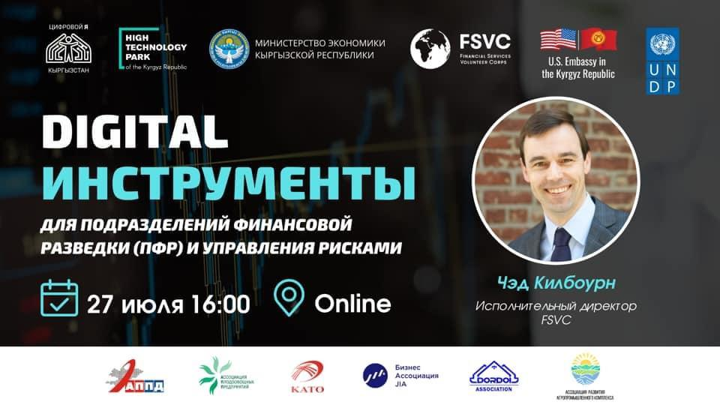 | https://www.facebook.com/116487388447179/posts/3109232152506006/?d=n  https://www.instagram.com/p/CDIedikjGqj/?igshid=4v2ei6hrwxoz
30 | July 2020  Joint development of illustration with HTP and Ololo. Promotion on UNDP channles. | How to continue learning during the Coronavirus era. | https://www.facebook.com/116487388447179/posts/3095747377187817/?d=n  https://www.instagram.com/p/CC8OhomDqAc/?igshid=m4800rv04m8n
31 | July 2020  Inno competition. Article. | A new methodology for improving teachers’ skills. About the winners of the Inno KG. | https://www.kg.undp.org/content/kyrgyzstan/en/home/presscenter/articles/2020/07/improving-teacher-skills-innovation-call.html  https://www.kg.undp.org/content/kyrgyzstan/ru/home/presscenter/articles/2020/07/improving-teacher-skills-innovation-call.html  https://www.kg.undp.org/content/kyrgyzstan/ky/home/presscenter/articles/2020/07/improving-teacher-skills-innovation-call.html  https://www.facebook.com/116487388447179/posts/3090047821091106/?d=n
32 | Article in the framework of anti-crisis communication | Статья: «E-hackathon participant: "I've been friends with E-technology since I was 5» | https://www.kg.undp.org/content/kyrgyzstan/ru/home/presscenter/articles/2020/05/e-hackathon-participant---i-ve-been-friends-with-e-technology-si.html?fbclid=IwAR21yKze52WlbbmhoJG_JV3Hmwhud6gL9GNytIjeFSp4Z0-z3OASAZymgDo  https://www.kg.undp.org/content/kyrgyzstan/en/home/presscenter/articles/2020/05/e-hackathon-participant---i-ve-been-friends-with-e-technology-si.html  https://www.facebook.com/116487388447179/posts/2895745830521307/?d=n  https://twitter.com/undpkg/status/1257593547731189760?s=20
33 | Programmers' stories (publication) | Stories of IT programmers, Hackathon participants - Tilek Egemberdiev and Daniil Kolodyazhny | https://www.facebook.com/116487388447179/posts/2897770400318850/?d=n  https://twitter.com/undpkg/status/1257925303307026433?s=20
34 | Post-release on the Hackathon, article in the BAYAN magazine | IT solutions developed by young people will help end domestic violence against women and children | https://www.kg.undp.org/content/kyrgyzstan/ru/home/presscenter/pressreleases/2020/05/it-solutions-developed-by-youth-will-help-to-cope-with-domestic-.html  https://www.kg.undp.org/content/kyrgyzstan/ky/home/presscenter/pressreleases/2020/05/it-solutions-developed-by-youth-will-help-to-cope-with-domestic-.html  https://www.kg.undp.org/content/kyrgyzstan/en/home/presscenter/pressreleases/2020/05/it-solutions-developed-by-youth-will-help-to-cope-with-domestic-.html  https://www.facebook.com/116487388447179/posts/2911830908912799/?d=n  https://twitter.com/undpkg/status/1260126254973489152?s=20
35 | Hackathon video | Video with the participants of the Hackathon and the heads of UNDP and UNICEF | https://www.facebook.com/116487388447179/posts/2930740207021869/?d=n  https://www.youtube.com/watch?v=lEm32Zpayz0&feature=youtu.be&fbclid=IwAR3jyJeU_njSbVsfGeE0R2Iw1jm3Od1Ti9nMuZEE1WhtrhFBxqd9qW7Ux0E  https://twitter.com/undpkg/status/1262613870876585985?s=20
36 | Article in the framework of anti-crisis communication | How COVID-19 is changing the world in numbers | https://www.kg.undp.org/content/kyrgyzstan/ru/home/presscenter/articles/2020/05/how-covid-19-changes-the-world-in-numbers.html  https://www.facebook.com/116487388447179/posts/2930922713670285/?d=n  https://twitter.com/undpkg/status/1262676858656653313?s=20
37 | Publication on the Digital Skills project | Premiere of the social film "Zhyldyz" | https://www.facebook.com/116487388447179/posts/2937526366343253/?d=n  https://www.facebook.com/watch/?v=277198283470050  https://twitter.com/undpkg/status/1263705013874024451?s=20
38 | Publication in the framework of anti-crisis communication | "How to have a productive online meeting with colleagues" | https://www.facebook.com/notes/undp-in-the-kyrgyz-republic/%D0%BA%D0%B0%D0%BA-%D0%BF%D1%80%D0%BE%D0%B2%D0%B5%D1%81%D1%82%D0%B8-%D0%BF%D1%80%D0%BE%D0%B4%D1%83%D0%BA%D1%82%D0%B8%D0%B2%D0%BD%D1%83%D1%8E-%D0%BE%D0%BD%D0%BB%D0%B0%D0%B9%D0%BD-%D0%B2%D1%81%D1%82%D1%80%D0%B5%D1%87%D1%83-%D1%81-%D0%BA%D0%BE%D0%BB%D0%BB%D0%B5%D0%B3%D0%B0%D0%BC%D0%B8/2948780478551175/  https://twitter.com/undpkg/status/1265487491496378371?s=20
39 | Publication in the framework of anti-crisis communication | "Kyrgyz women in IT, who are they?" | https://www.facebook.com/116487388447179/posts/2953595414736348/?d=n  https://twitter.com/undpkg/status/1266240592301838336?s=20
40 | Article within the Digital Skills project 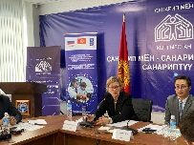 | Article: Towards the digital transformation of Kyrgyzstan: on e-government and ICT, photography, Note: "UNDP supported the day of career and practice at KSTU named after Razzakov", photos, coverage in social networks. | https://www.kg.undp.org/content/kyrgyzstan/ru/home/presscenter/pressreleases/2020/03/towards-kyrgyzstans-digital-transformation--e-government-and-ict.html  https://flickr.com/photos/undpkg/albums/72157713432889301
41 | Development of a banner for the Hackathon in cooperation with Unicef. | Development of a banner for the Hackathon.  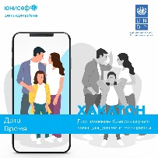 | 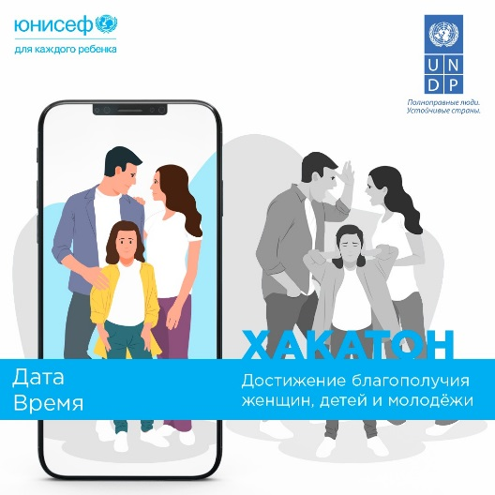
42 | Publication in the framework of anti-crisis communication | "Online route sheets for movement in the city"  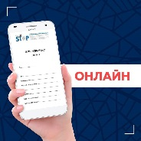 | https://www.facebook.com/photo/?fbid=2806287442800480&set=a.153455198083731
43 | Publication in the framework of anti-crisis communication | Interview with IT programmer - Dinara Ruslan | https://www.facebook.com/undpkg/posts/2807060246056533
44 | Publication in the framework of anti-crisis communication | "Check yourself for symptoms of coronavirus infection without leaving home"  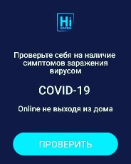 | https://www.facebook.com/undpkg/posts/2802409523188272
45 |  | UNDP supported the development of a telemedicine application  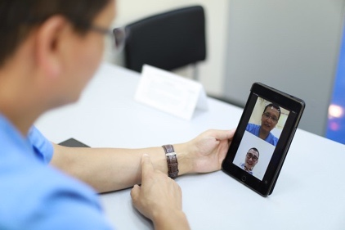 | https://www.kg.undp.org/content/kyrgyzstan/en/home/presscenter/pressreleases/2020/12/undp-supported-the-development-of-a-telemedicine-application.html  https://www.kg.undp.org/content/kyrgyzstan/ru/home/presscenter/pressreleases/2020/12/undp-supported-the-development-of-a-telemedicine-application.html  https://www.kg.undp.org/content/kyrgyzstan/ky/home/presscenter/pressreleases/2020/12/undp-supported-the-development-of-a-telemedicine-application.html  https://www.facebook.com/undpkg/posts/3496479460447938  https://www.instagram.com/p/CIUqxHRD8gy/?igshid=wcfuqm4xmxd6
46 |  | Oracle comes to Kyrgyzstan - prospects and hopes  Developing illustration | https://www.kg.undp.org/content/kyrgyzstan/en/home/presscenter/articles/2020/12/oracle-comes-to-kyrgyzstan---prospects-and-hopes.html  https://www.kg.undp.org/content/kyrgyzstan/ky/home/presscenter/articles/2020/12/oracle-comes-to-kyrgyzstan---prospects-and-hopes.html  https://www.kg.undp.org/content/kyrgyzstan/ru/home/presscenter/pressreleases/2020/12/oracle-comes-to-kyrgyzstan---prospects-and-hopes.html
47 |  | How mobile applications have opened doors for children with hearing loss  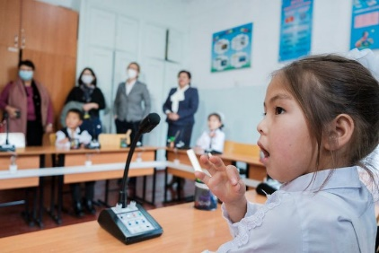 | https://www.kg.undp.org/content/kyrgyzstan/en/home/presscenter/articles/2020/12/how-mobile-applications-have-opened-doors-for-children-with-hear.html  https://www.kg.undp.org/content/kyrgyzstan/ru/home/presscenter/articles/2020/12/how-mobile-applications-have-opened-doors-for-children-with-hear.html  https://www.kg.undp.org/content/kyrgyzstan/ky/home/presscenter/pressreleases/2020/12/how-mobile-applications-have-opened-doors-for-children-with-hear.html
48 |  | Top 10 popular courses on Coursera among Kyrgyz citizens  Developing illustration | https://www.kg.undp.org/content/kyrgyzstan/en/home/presscenter/pressreleases/2020/12/top-10-courses-kyrgyzstan.html  https://www.kg.undp.org/content/kyrgyzstan/ru/home/presscenter/articles/2020/12/top-10-courses-kyrgyzstan.html  https://www.facebook.com/116487388447179/posts/3478954502200434/?d=n  https://www.instagram.com/p/CISsWY8MBU3/?igshid=5aq477qx5d7q
49 |  | Two Kyrgyz universities and an institute are connected to international educational services  Developing illustration | https://www.kg.undp.org/content/kyrgyzstan/en/home/presscenter/articles/2020/11/universities-on-line.html  https://www.kg.undp.org/content/kyrgyzstan/ru/home/presscenter/articles/2020/11/universities-on-line.html  https://www.kg.undp.org/content/kyrgyzstan/ky/home/presscenter/articles/2020/11/universities-on-line.html
50 |  | Developing of high-quality content and promotion in social media. Distribution illustration about webinar  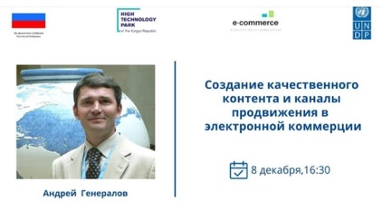 | https://www.facebook.com/undpkg/posts/3482009291894955  https://www.instagram.com/p/CIVgv-8s233/?igshid=10qbudpp7ms2d
51 |  | Webinar on copywriting skills. Developing and distribution illustration about webinar  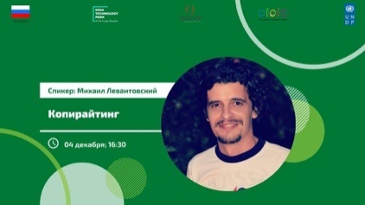 | https://www.facebook.com/undpkg/posts/3479345068828044
52 |  | Webinar possibilities for e-commerce. Distribution of webinar. 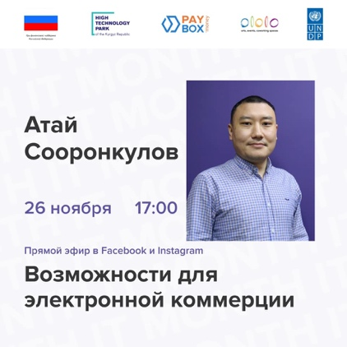 | https://www.facebook.com/undpkg/posts/3457187167710501  https://www.instagram.com/p/CH9493GjExr/?igshid=19xn9x447lecn
53 |  | Legal aspects of HTP activities in Kyrgyzstan. Distribution of webinar. 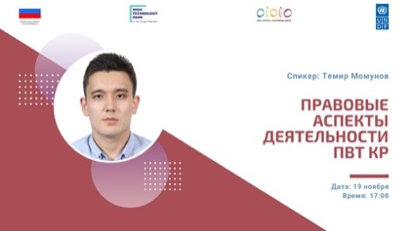 | https://www.facebook.com/undpkg/posts/3440972399331978  https://www.instagram.com/p/CHt5W_zD3MS/?igshid=13hjnoixebyeo
54 |  | SEO webinar. Distribution.  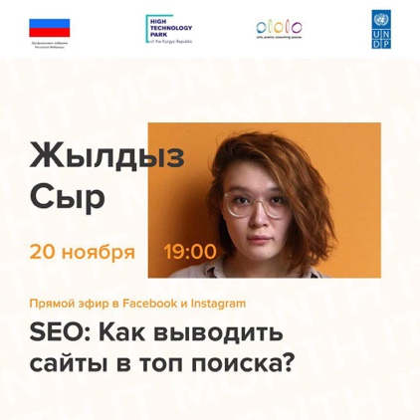 | https://www.facebook.com/undpkg/posts/3438989892863562  https://www.instagram.com/p/CHsJLiEDIFx/?igshid=jt9dgmsiugf5
55 |  | Webinar on Agile Product development. 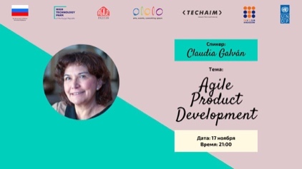 | https://www.facebook.com/undpkg/posts/3438622466233638  https://www.instagram.com/p/CHryLbgDofQ/?igshid=17ut2a37gnng3
56 |  | Women in IT. Webinar with Tech-Aiym Aiturgan Zulpukarova. | https://www.facebook.com/undpkg/posts/3416438751785343  https://www.instagram.com/p/CHWuZ-_DwDQ/?igshid=79v4el7tszp7
57 |  | Graphic design and animation. Webinar with Benazir Kalieva and Mar Amandykov. 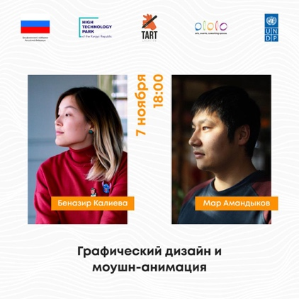 | https://www.facebook.com/undpkg/posts/3405632792865939  https://www.instagram.com/p/CHMauX9D5af/?igshid=yrxicf108r5
58 |  | STAN Agile in Central Asia. Webinar with IT experts.  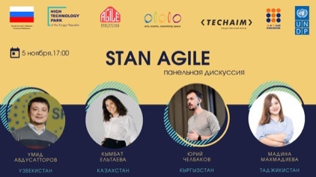 | https://www.facebook.com/undpkg/posts/3403029659792919  https://www.instagram.com/p/CHJ42EkjIMS/?igshid=3hjdz0q199cm

Internet publications that supported SCITC on Sanarip Kyrgyzstan
- http://kabar.kg/news/iatc-kabar-tcifrovaia-modernizatciia-tamozhennykh-punktov-dlia-iskliucheniia-korruptcii/
- 6.12.2019 - http://www.tazabek.kg/news:1583569?place=rec-news&from=tazabek
- 12.12.2019 - http://www.tazabek.kg/news:1584926/
- 13.12.2019 - http://ru.reporter.kg/v-kyrgyzstane-poiaviatsia-5g-i-internet-veshchei/
- 13.12.2019 - https://www.akchabar.kg/ru/news/v-kyrgyzstane-nachnut-testirovat-5g/
- https://digital.gov.kg/category/%d0%bd%d0%be%d0%b2%d0%be%d1%81%d1%82%d0%b8-%d0%b8-%d0%b0%d0%bd%d0%be%d0%bd%d1%81%d1%8b
- https://www.instagram.com/sanarip.kyrgyzstan/
- https://www.facebook.com/sanarip.kgz/
- http://www.ict.gov.kg/index.php?r=site%2Fevent&cid=7&eid=172
- https://www.figma.com/file/tGxXHjYLC04UE0NirwhL6E/Digital-skills?node-id=0%3A1
- https://docs.google.com/spreadsheets/d/1rJRIr44cC0wht7I5bJGZje7snOAf9GkML9RNaID1DvY/edit#gid=0
- https://docs.google.com/spreadsheets/d/1HolwoRVCoRBjIiXIKuHDuARhLHiQJFU7OXV1oqO46v8/edit#gid=0
- http://ict.gov.kg/index.php?r=site%2Fpress&pid=550&cid=1
- http://ict.gov.kg/index.php?r=site%2Fpress&pid=551&cid=1
- https://digital.gov.kg/2020/04/10/%d0%a1%d1%82%d0%b0%d1%80%d1%82%d0%be%d0%b2%d0%b0%d0%bb%d0%b0-%d0%b2%d1%82%d0%be%d1%80%d0%b0%d1%8f-%d0%b2%d0%be%d0%bb%d0%bd%d0%b0-%d0%b8%d0%bd%d1%84%d0%be%d1%80%d0%bc%d0%b0%d1%86%d0%b8%d0%be%d0%bd-2/
- https://digital.gov.kg/kg/2020/04/10/%d0%a1%d0%b0%d0%bd%d0%b0%d1%80%d0%b8%d0%bf-%d0%b0%d0%bb%d0%b8%d0%bf%d0%bf%d0%b5-%d0%bc%d0%b0%d0%b0%d0%bb%d1%8b%d0%bc%d0%b0%d1%82%d1%82%d1%8b%d0%ba-%d0%b0%d0%b3%d0%b0%d1%80%d1%82%d1%83%d1%83-%d0%b4/
- http://ict.gov.kg/index.php?r=site%2Fpress&pid=510&cid=1
- http://ict.gov.kg/index.php?r=site%2Fpress&pid=551&cid=1
- https://digital.gov.kg/kg/2020/02/07/%d0%a1%d0%b0%d0%bd%d0%b0%d1%80%d0%b8%d0%bf-%d0%90%d0%bb%d0%b8%d0%bf%d0%bf%d0%b5-%d0%b0%d0%b3%d0%b0%d1%80%d1%82%d1%83%d1%83%d1%87%d1%83%d0%bb%d1%83%d0%ba-%d0%b4%d0%be%d0%bb%d0%b1%d0%be/
- https://digital.gov.kg/kg/2020/04/10/%d0%a1%d0%b0%d0%bd%d0%b0%d1%80%d0%b8%d0%bf-%d0%b0%d0%bb%d0%b8%d0%bf%d0%bf%d0%b5-%d0%bc%d0%b0%d0%b0%d0%bb%d1%8b%d0%bc%d0%b0%d1%82%d1%82%d1%8b%d0%ba-%d0%b0%d0%b3%d0%b0%d1%80%d1%82%d1%83%d1%83-%d0%b4/
- https://digiskills.kg/news/10
- https://digiskills.kg/news/15
- http://ict.gov.kg/index.php?r=site%2Fpress&pid=538&cid=1
- http://ict.gov.kg/index.php?r=site%2Fpress&pid=534&cid=1
- http://ict.gov.kg/index.php?r=site%2Fpress&pid=530&cid=1
- http://ict.gov.kg/index.php?r=site%2Fpress&pid=545&cid=1
- http://ict.gov.kg/index.php?r=site%2Fpress&pid=544&cid=1
- http://ict.gov.kg/index.php?r=site%2Fpress&pid=540&cid=1
- http://ict.gov.kg/index.php?r=site%2Fpress&pid=536&cid=1
- http://ict.gov.kg/index.php?r=site%2Fpress&pid=533&cid=1
- http://ict.gov.kg/index.php?r=site%2Fpress&pid=532&cid=1
- http://ict.gov.kg/index.php?r=site%2Fpress&pid=531&cid=1
- http://ict.gov.kg/index.php?r=site%2Fpress&pid=529&cid=1
- http://ict.gov.kg/index.php?r=site%2Fpress&pid=528&cid=1
- http://ict.gov.kg/index.php?r=site%2Fpress&pid=525&cid=1
- http://ict.gov.kg/index.php?r=site%2Fpress&pid=523&cid=1
- http://ict.gov.kg/index.php?r=site%2Fpress&pid=522&cid=1
- http://ict.gov.kg/index.php?r=site%2Fpress&pid=548&cid=1
- http://ict.gov.kg/index.php?r=site%2Fpress&pid=555&cid=1
- https://digital.gov.kg/2020/04/15/it-%d0%a8%d1%82%d0%b0%d0%b1-%d0%bf%d1%80%d0%b8-%d0%93%d0%9a%d0%98%d0%a2%d0%b8%d0%a1-%d0%b7%d0%b0%d0%bf%d1%83%d1%89%d0%b5%d0%bd-%d1%80%d0%b5%d1%81%d1%83%d1%80%d1%81-%d0%bf%d0%be-%d0%bc%d0%be%d0%bd/
- https://digital.gov.kg/2020/03/27/%d0%97%d0%b0%d0%bf%d1%83%d1%89%d0%b5%d0%bd-%d0%be%d0%bd%d0%bb%d0%b0%d0%b9%d0%bd-%d1%80%d0%b5%d1%81%d1%83%d1%80c-%d0%bf%d0%be-%d1%81%d0%bf%d0%b5%d1%86%d1%81%d1%87%d0%b5%d1%82%d1%83-%d0%bf%d0%be-%d0%b1/
- https://digital.gov.kg/2020/03/25/it-%d1%88%d1%82%d0%b0%d0%b1-%d0%bd%d0%b0%d1%87%d0%b0%d0%bb-%d1%80%d0%b0%d0%b1%d0%be%d1%82%d1%83-%d0%bd%d0%b0%d0%b4-%d0%bf%d1%80%d0%b8%d0%bb%d0%be%d0%b6%d0%b5%d0%bd%d0%b8%d0%b5%d0%bc-%d0%bf%d0%be/
- https://digital.gov.kg/2020/03/24/%d0%ad%d0%ba%d1%81%d1%82%d1%80%d0%b5%d0%bd%d0%bd%d1%8b%d0%b9-it-%d1%88%d1%82%d0%b0%d0%b1-%d0%b7%d0%b0%d0%bf%d1%83%d1%81%d1%82%d0%b8%d0%bb-%d0%ba%d1%8b%d1%80%d0%b3%d1%8b%d0%b7%d1%81%d0%ba%d0%be%d1%8f/
- https://digital.gov.kg/2020/03/23/%d0%97%d0%b0%d0%bf%d1%83%d1%89%d0%b5%d0%bd%d1%8b-%d1%81%d0%bf%d0%b5%d1%86-%d1%80%d0%b5%d1%81%d1%83%d1%80%d1%81%d1%8b-hidoctor-kg-covid-gov-kg-covid-kg/
- https://digital.gov.kg/2020/03/20/%d0%ad%d0%ba%d1%81%d1%82%d1%80%d0%b5%d0%bd%d0%bd%d1%8b%d0%bc-it-%d1%88%d1%82%d0%b0%d0%b1%d0%be%d0%bc-%d0%bf%d1%80%d0%b8-%d0%93%d0%9a%d0%98%d0%a2%d0%b8%d0%a1-%d0%b7%d0%b0%d0%bf%d1%83%d1%89%d0%b5%d0%bd/
- https://digital.gov.kg/2020/03/20/%d0%ad%d0%ba%d1%81%d1%82%d1%80%d0%b5%d0%bd%d0%bd%d1%8b%d0%b9-it-%d1%88%d1%82%d0%b0%d0%b1-%d0%bf%d1%80%d0%b8-%d0%93%d0%9a%d0%98%d0%a2%d0%b8%d0%a1/
- https://digital.gov.kg/kg/2020/04/15/%d0%93%d1%83%d0%bc-%d0%b6%d0%b0%d1%80%d0%b4%d0%b0%d0%bc-%d0%ba%d0%b5%d0%bb%d0%b8%d0%bf-%d1%82%d2%af%d1%88%d2%af%d2%af%d1%81%d2%af%d0%bd%d3%a9-%d0%b0%d0%bd%d1%8b%d0%bd-%d0%b1%d3%a9%d0%bb%d2%af%d1%88/
- https://digital.gov.kg/kg/2020/03/24/%d3%a8%d0%b7%d0%b3%d1%b3%d1%87%d1%b3-%d0%ba%d1%8b%d1%80%d0%b4%d0%b0%d0%b0%d0%bb%d0%b4%d0%b0%d0%b3%d1%8b-it-%d1%88%d1%82%d0%b0%d0%b1%d1%8b%d0%bd%d1%8b%d0%bd-%d0%b8%d1%88%d0%b8%d0%bd%d0%b8%d0%bd-%d0%b0/
- http://ict.gov.kg/index.php?r=site%2Fpress&pid=545&cid=1
- http://ict.gov.kg/index.php?r=site%2Fpress&pid=525&cid=1
- http://ict.gov.kg/index.php?r=site%2Fpress&pid=540&cid=1
- https://digital.gov.kg/2020/04/04/%d0%a4%d0%b5%d0%b9%d0%ba%d0%b8-%d0%be-5g-%d0%b2-%d0%9a%d1%8b%d1%80%d0%b3%d1%8b%d0%b7%d1%81%d1%82%d0%b0%d0%bd%d0%b5-%d0%b8-%d1%80%d0%b0%d0%b4%d0%b8%d0%be%d1%84%d0%be%d0%b1%d0%b8%d1%8f/
- https://digital.gov.kg/2020/04/03/%d0%9a%d0%b8%d0%b1%d0%b5%d1%80%d0%bf%d0%b0%d0%bd%d0%b4%d0%b5%d0%bc%d0%b8%d1%8f-%d0%bd%d0%b0%d0%b1%d0%bb%d1%8e%d0%b4%d0%b0%d0%b5%d1%82%d1%81%d1%8f-%d1%83%d0%b2%d0%b5%d0%bb%d0%b8%d1%87%d0%b5%d0%bd/
- https://digital.gov.kg/2020/04/03/%d0%94%d0%be%d1%81%d1%82%d1%83%d0%bf-%d0%b2-%d0%b8%d0%bd%d1%82%d0%b5%d1%80%d0%bd%d0%b5%d1%82-%d0%be%d1%81%d1%83%d1%89%d0%b5%d1%81%d1%82%d0%b2%d0%bb%d1%8f%d0%b5%d1%82%d1%81%d1%8f-%d0%b2-%d1%88%d1%82/
- Ала Тоо 24 - https://youtu.be/VU1M9MrKeM4
- ЭлТР - https://youtu.be/Zyr1VT3P3I8
- https://ru.pyramida.kg/proversya-onlajn-na-koronavirus-kakie-eshhyo-spetsresursy-podgotovilo-it-soobshhestvo/#.XnozWclXr78.facebook (ТРК «Пирамида»)
- https://www.youtube.com/watch?v=9rJ-eDkQOWc (Телеканал «Ала Тоо 24»)
- https://www.youtube.com/watch?v=geTuXn64Tz0 (МТРК «ЭлТР»)
- http://kabar.kg/news/obrazovan-ekstrennyi-it-shtab-dlia-podderzhki-respublikanskogo-shtaba-po-bor-be-s-covid-19/
- http://kabar.kg/news/it-shtab-zapushchen-resurs-po-monitoringu-postupleniia-i-raspredeleniia-gumpomoshchi/
- http://kabar.kg/news/zapushchena-onlain-sistema-dlia-polucheniia-elektronnogo-razresheniia-na-peredvizhenie-v-gg.osh-i-dzhalal-abad-v-period-chp/
- https://elgezit.kg/2020/03/26/ekstrennyj-it-shtab-pri-goskomsvyazi-kr-predlozhil-ryad-tsifrovyh-reshenij-v-borbe-s-koronavirusom/
- https://elgezit.kg/2020/03/27/it-shtab-pri-goskomsvyazi-kr-zapustil-onlajn-resurs-dlya-prozrachnogo-sbora-denezhnyh-sredstv/
- https://vesti.kg/obshchestvo/item/69746-ekstrennyj-it-shtab-zapustil-chat-bot-po-situatsii-s-koronavirusom.html
- https://economist.kg/2020/03/20/v-kyrgyzstane-sozdali-it-shtab-dlya-pomoshhi-v-borbe-s-koronavirusom/
- https://www.for.kg/news-641231-ru.html
Sanarip Kyrgyzstan logo developed

SMM Supported web links
- https://www.instagram.com/p/B5cRmpIlSZS/
- https://www.instagram.com/p/B5miK9ylqbP/
- https://www.instagram.com/p/B5nLpvHF8wP/
- https://www.instagram.com/p/B5sFrIdlhPU/
- https://www.instagram.com/p/B5urTWjFMvi/
- https://www.instagram.com/p/B55DbZll85w/
- https://www.instagram.com/p/B6M3nN4lq5H/
- https://www.instagram.com/p/B6NlXyqFB9e/
- https://www.instagram.com/p/B6QoxNhFs8s/
- https://www.facebook.com/sanarip.kgz/photos/a.437421397179968/437421147179993/?type=3&theater
- https://www.facebook.com/sanarip.kgz/photos/a.437421397179968/440799356842172/?type=3&theater
- https://www.facebook.com/sanarip.kgz/photos/a.437421397179968/442541453334629/?type=3&theater
- https://www.facebook.com/sanarip.kgz/photos/a.437421397179968/443399276582180/?type=3&theater
- https://www.facebook.com/sanarip.kgz/photos/a.437421397179968/446853962903378/?type=3&theater
- https://www.facebook.com/sanarip.kgz/photos/a.437421397179968/453690252219749/?type=3&theater
- https://www.facebook.com/sanarip.kgz/photos/a.437421397179968/453901418865299/?type=3&theater
- https://www.facebook.com/sanarip.kgz/photos/a.437421397179968/454933535428754/?type=3&theater
- https://www.facebook.com/sanarip.kgz/videos/2650742085011332/?__xts__[0]=68.ARD3of1O_Vo_vy0Yvr2ovHbLzmtZBWDmV8nVK0JN2PrCD3adpuVJTz8U6KBwNziLrtwqShVlyrSCl_2C35SIBVJ65huwkVBhP12rqzyGxkGM1no5Oof-fQfc8A3n4-iyFytd4mDOiD8PnJCtQQGh8rOTN9JMBrAnLWIzM_FV_OeDLXOEKyYustfgAgLdcwDVuW7WQrArR7cpMtrY37u4BDG3JEEgey9GAJGCvrOnBSkjnVcYaGPR_-MsXIlV-KAFf4yW3CDw71clm-Q9Px4lNiULuiFaRN6u_po_R3CqmQK9-ExiLK-ClzG4GXW49uJ6h2C1pS1Xml3Z4E7piZv1IzpckOgRrsSpNBxgHRqipe51&__tn__=-R

Created communications for sites - 20 communications
- A marathon of online events on technologies “Digital Economy in the Kyrgyz Republic” has started.
http://www.ict.gov.kg/index.php?r=site%2Fpress&pid=577&cid=1
- False information about the dangers of 5G technologyhttp://www.ict.gov.kg/index.php?r=site%2Fpress&pid=578&cid=1
- Schedule of 2 weeks of webinars for the "Digital Economy in the Kyrgyz Republic" marathon
http://www.ict.gov.kg/index.php?r=site%2Fpress&pid=579&cid=1
- Key findings of the webinars of the first week of the Digital Economy marathon http://www.ict.gov.kg/index.php?r=site%2Fpress&pid=580&cid=1
- Kyrgyzstan ranked second among Central Asian countries in terms of the level of e-government development.http://www.ict.gov.kg/index.php?r=site%2Fpress&pid=585&cid=1
- Digital solutions for the health care system of the Kyrgyz Republic
http://www.ict.gov.kg/index.php?r=site%2Fpress&pid=588&cid=1
- International speakers at the Digital Economy online marathon
http://www.ict.gov.kg/index.php?r=site%2Fpress&pid=590&cid=1
- Schedule of 3 weeks of webinars of the "Digital Economy in the Kyrgyz Republic" marathon
http://www.ict.gov.kg/index.php?r=site%2Fpress&pid=593&cid=1
- Cell Tower Security
http://www.ict.gov.kg/index.php?r=site%2Fpress&pid=592&cid=1
- Key findings of the webinars of the second week of the Digital Economy marathon
http://www.ict.gov.kg/index.php?r=site%2Fpress&pid=595&cid=1
- An interactive online map of deployed hospitals and hospitals has been developed https://map.covid.kg
http://www.ict.gov.kg/index.php?r=site%2Fpress&pid=599&cid=1
- Earning opportunities for young people in the context of coronavirus crisis from K. Alyshbaev.
https://www.facebook.com/259279748327468/posts/611782053077234/?d=n
- Schedule of the 4th week of webinars of the Digital Economy marathon
http://www.ict.gov.kg/index.php?r=site%2Fpress&pid=603&cid=1
- Key conclusions of the webinars of the third week of the digital economy marathon http://www.ict.gov.kg/index.php?r=site%2Fpress&pid=601&cid=1
- Digital transformation vs digitalization.
http://www.ict.gov.kg/index.php?r=site%2Fpress&pid=605&cid=1
- Review of digital solutions of domestic IT specialists
http://www.ict.gov.kg/index.php?r=site%2Fpress&pid=607&cid=1
- Results of the week "Digital Economy"
http://www.ict.gov.kg/index.php?r=site%2Fpress&pid=610&cid=1
- Final webinars of the online marathon with international speakers.
http://www.ict.gov.kg/index.php?r=site%2Fpress&pid=611&cid=1
- Online meeting on the status of work of state-owned enterprises in the field of IT
http://www.ict.gov.kg/index.php?r=site%2Fpress&pid=612&cid=1
- COVID.KG - A single information platform about the situation with coronavirus in the country
http://www.ict.gov.kg/index.php?r=site%2Fpress&pid=613&cid=120
Posted news feeds in state media
KNIA "Kabar"
- http://kabar.kg/news/startoval-marafon-onlain-meropriiatii-o-tekhnologiiakh-tcifrovaia-ekonomika-v-kr/
- http://kabar.kg/news/goskomsviazi-planiruet-vydavat-rezul-taty-analizov-na-covid-19-v-rezhime-onlain/
- http://kabar.kg/news/v-goskomsviazi-razrabotali-platformy-dlia-informirovaniia-naseleniia-o-covid-19/
- http://kg.kabar.kg/news/covid-19-kyrgyzstanda-kandai-maalymattyk-sistemalar-ishtelip-chyguuda/
- http://kabar.kg/news/kyrgyzstan-zanial-ii-mesto-sredi-sran-tca-po-urovniu-razvitiia-elektronnogo-pravitel-stva/
- http://kabar.kg/news/provedeny-zameru-urovnia-izluchenii-oborudovaniia-sotovoi-sviazi-v-bishkeke-gkitis/
- http://kabar.kg/news/teper-mozhno-uznat-gde-est-svobodnye-koiko-mesta-razrabotana-elektronnaia-sistema-dannykh/
- http://kg.kabar.kg/news/bishkekte-oorukanalardagy-bosh-orundarga-monitoring-zh-rg-z-turgan-sistema-ishke-kirdi/
- http://kabar.kg/news/razrabotana-interaktivnaia-onlain-karta-razvernutykh-statcionarov-i-bol-nitc/

KTRK, ALATOO 24
- https://www.youtube.com/watch?v=2O4nfnan8hE&feature=share&fbclid=IwAR0B02FwN3zROIYyi8Iev8zCu83k2FYWyzFqiqvrfcxDd4xz5u0ihaJZtks
- https://www.youtube.com/watch?v=_S6_J-XO_2M
- https://www.youtube.com/watch?v=J3tV5wly0Sk
- https://www.youtube.com/watch?v=IiZ3PXEztCk
- https://www.youtube.com/watch?v=KtyRvoj9-vg
- https://youtu.be/pv737lD6m0Y
- https://youtu.be/rzgrmjsQs1k
- https://www.youtube.com/watch?v=rWvd0FZOUF4&t=3s
- https://youtu.be/2BTG2L4-_yI
- https://youtu.be/_q5TGq0goxc

ELTR
- https://youtu.be/PEEtodoAVgw (from 21:50 mins)
- https://youtu.be/DOLVpIW5j4g
- https://youtu.be/7XYhcKLcVtw
- https://youtu.be/yepqIFVp0Ec

Pyramid
- https://youtu.be/D9RncqM_fGw

Since July 25, the placement in the state media has been additionally worked out.
https://youtu.be/HyJ10zsR0rk
https://youtu.be/K5DDBMCts_U http://kabar.kg/news/v-kyrgyzstane-rabotaet-platforma-gde-ob-edinena-vsia-informatciia-o-koronaviruse-covid.kg/
https://youtu.be/ktWuC3McWTI http://kabar.kg/news/predsedatel-gkitis-rasskazal-o-preimushchestvakh-obnovlennogo-saita-covid-19/
https://reporter.kg/kyrgyzstanda-covid-kg-atalyshyndagy-zha%d2%a3yrtylgan-sajt-ishtep-bashtady/
http://kabar.kg/news/zapushchen-obnovlennyi-sait-covid.kg-edinaia-ploshchadka-o-situatcii-s-koronavirusom-v-kr/
https://www.facebook.com/watch/?v=1615196875354161
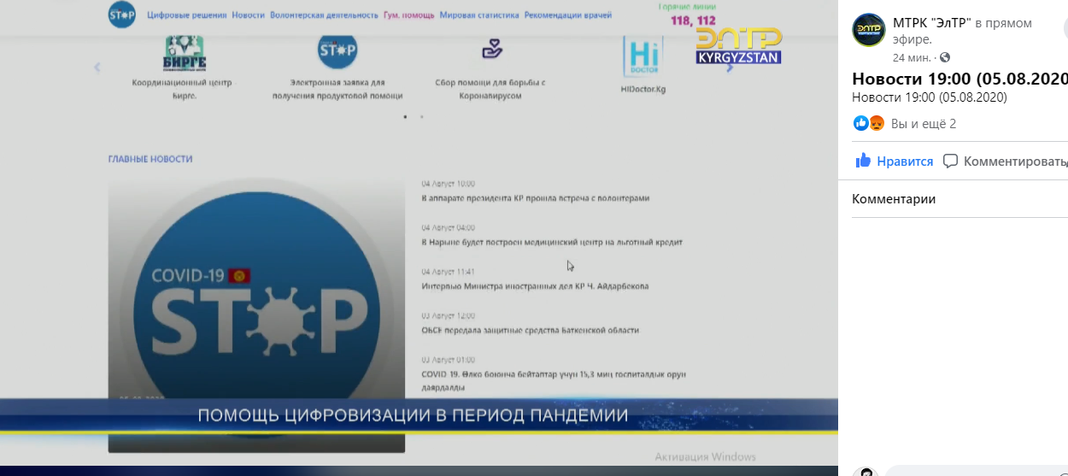

- https://www.facebook.com/watch/?v=1615196875354161
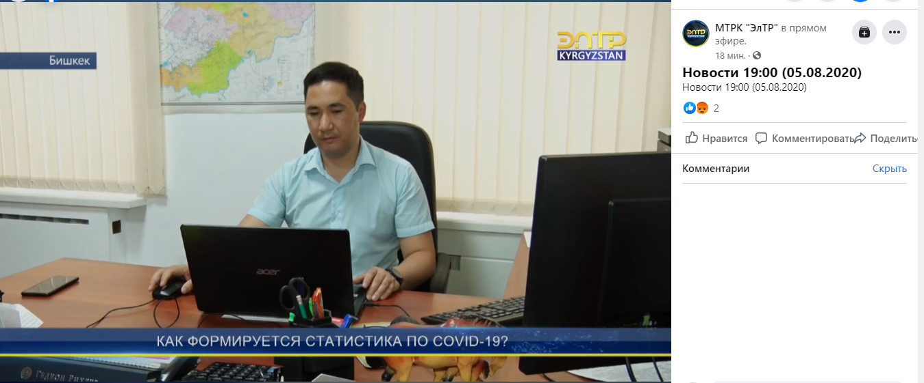

http://kabar.kg/news/sostoialos-onlain-soveshchanie-po-statusu-rabot-gospredpriiatii-kr-v-oblasti-it/
http://www.tazabek.kg/news:1637169?from=portal&place=last&b=8 http://kabar.kg/news/sistema-sanarip-aimak-integrirovana-s-smev-tunduk-grs-kr/
https://youtu.be/tB4aynlAY-E https://youtu.be/FqTqkDX4MJc

1. Akipress - http://www.tazabek.kg/news:1637169?from=portal&place=last&b=8
2. Kabar - http://kabar.kg/news/sistema-sanarip-aimak-integrirovana-s-smev-tunduk-grs-kr/
3. AlaToo 24 - https://youtu.be/tB4aynlAY-E
1. http://www.tazabek.kg/news:1637004
2. http://kabar.kg/news/sostoialos-onlain-soveshchanie-po-statusu-rabot-gospredpriiatii-kr-v-oblasti-it/
https://kaktus.media/doc/417311_kyrgyzstan_zanial_vtoroe_mesto_sredi_stran_ca_po_yrovnu_razvitiia_elektronnogo_pravitelstva.html
https://kaktus.media/doc/415670_dastan_dogoev_vozglavit_klyb_cifrovyh_liderov_i_koordinaciu_cifrovizacii_strany.html
https://kaktus.media/doc/418189_naskolko_ty_digital_test_na_znanie_koncepcii_sanarip_kyrgyzstan.html

Placement of 20 of these news events on the website and 29 in the social networks of Sanarip KR.

1.https://www.facebook.com/259279748327468/posts/600220360900070/?d=n
2.https://www.facebook.com/259279748327468/posts/601130427475730/?d=n
3.https://www.facebook.com/259279748327468/posts/603735063881933/?d=n
4.https://www.facebook.com/259279748327468/posts/603868567201916/?d=n
5.https://www.facebook.com/259279748327468/posts/603938937194879/?d=n
6.https://www.facebook.com/259279748327468/posts/605243530397753/?d=n
7.https://www.facebook.com/259279748327468/posts/606062003649239/?d=n
8.https://www.facebook.com/259279748327468/posts/608087140113392/?d=n
9.https://www.facebook.com/259279748327468/posts/608715273383912/?d=n
10.https://www.facebook.com/259279748327468/posts/608725493382890/?d=n
11.https://www.facebook.com/259279748327468/posts/609598876628885/?d=n
12. https://www.facebook.com/259279748327468/posts/611782053077234/?d=n

Posted news feeds on social networks - 29 posts
№ | Пост | Соцсеть | Ссылка
1 | Клуб цифровых лидеров | instagram | https://www.instagram.com/p/CBxe1Ajj50k/
 |  | Facebook | https://www.facebook.com/sanarip.kgz/posts/588798418708931
2 | Цифровые решения для системы здравоохранения КР | instagram | https://www.instagram.com/p/CCn7WeBhMPx/
 |  | Facebook | https://www.facebook.com/sanarip.kgz/posts/603938937194879
3 | Уровень развития e-правительства КР | instagram | https://www.instagram.com/p/CCnJmDoh5kh/
 |  | Facebook | https://www.facebook.com/sanarip.kgz/posts/603735063881933
4 | Индекс уровня е- правительства ООН | Instagram | https://www.instagram.com/p/CCsioGCh1Q1/
 |  | facebook | https://www.facebook.com/sanarip.kgz/posts/603938937194879
5 | Онлайн ресурс map.covid.kg | Instagram | https://www.instagram.com/p/CC5Gaq_B4PA/
 |  | facebook | https://www.facebook.com/sanarip.kgz/posts/608715273383912
6 | "Цифровые навыки и возможности для трудовой занятости молодежи в условиях цифровой экономики" | Instagram | https://www.instagram.com/p/CDDzU7UBfL8/
 |  | facebook | https://www.facebook.com/sanarip.kgz/posts/611782053077234
7 | Обзор смарт решений отечественных IT специалистов | Instagram | https://www.instagram.com/p/CDGpRAjBRZ7/
 |  | facebook | https://www.facebook.com/sanarip.kgz/posts/612572372998202
8 | Ключевые элементы цифровой трансформации | Instagram | https://www.instagram.com/p/CDGxvsmB6iv/
 |  | facebook | https://www.facebook.com/sanarip.kgz/posts/612614602993979
9 | Расписание вебинаров марафона 2 недели «Цифровая экономика КР» | instagram | https://www.instagram.com/p/CCa4mEwjdL_/
10 | Ключевые выводы вебинаров первой недели марафона «Цифровая экономика КР» | instagram | https://www.instagram.com/p/CCduMZUD1jk/
 |  | Facebook | https://www.facebook.com/sanarip.kgz/posts/601130427475730
11 | Международные спикеры на онлайн марафоне «Цифровая экономика КР» | instagram | https://www.instagram.com/p/CCnsurYhfL3/
 |  | Facebook | https://www.facebook.com/sanarip.kgz/posts/603868567201916
12 | Расписание вебинаров марафона 3 недели «Цифровая экономика КР» | Instagram | https://www.instagram.com/p/CCvcKLkBnVY/
 |  | facebook | https://www.facebook.com/sanarip.kgz/posts/606062003649239
13 | Ключевые выводы вебинаров второй недели марафона «Цифровая экономика КР» | Instagram | https://www.instagram.com/p/CC2ve8fBDuU/
 |  | facebook | https://www.facebook.com/sanarip.kgz/posts/608087140113392
14 | Чат-боты и автоматизация бизнес-процессов | Instagram | https://www.instagram.com/p/CC24TEpBh7w/
15 | ИТ инструменты для B2B в сфере сельского хозяйства | Instagram | https://www.instagram.com/p/CC5IOeKhRto/
 |  | facebook | https://www.facebook.com/sanarip.kgz/posts/608725493382890
16 | Маркетинг во время пандемии | Instagram | https://www.instagram.com/p/CC8RINwBGnN/
 |  | facebook | https://www.facebook.com/sanarip.kgz/posts/609598876628885
17 | Ключевые выводы вебинаров третей недели марафона «Цифровая экономика КР» | instagram | https://www.instagram.com/p/CDEOxeIBWGX/
 |  | Facebook | https://www.facebook.com/sanarip.kgz/posts/611913639730742
18 | Расписание вебинаров марафона 4 недели «Цифровая экономика КР» | instagram | https://www.instagram.com/p/CDGB0q_hs_1/
 |  | Facebook | https://www.facebook.com/sanarip.kgz/posts/612412876347485
19 | Digital инструменты для подразделений финансовой разведки и управления рисками | instagram | https://www.instagram.com/p/CDGVCzTBpj-/
 |  | Facebook | https://www.facebook.com/sanarip.kgz/posts/612488483006591
20 | Слайд-шоу о марафоне «Цифровая экономика КР» | instagram | https://www.instagram.com/p/CDGjd9ThCih/
 |  | Facebook | https://www.facebook.com/sanarip.kgz/posts/612549076333865
21 | Цифровизация ЖКХ | instagram | https://www.instagram.com/p/CDG7fFtBd6S/
 |  | Facebook | https://www.facebook.com/sanarip.kgz/posts/612659736322799
22 | Технологии блокчейн | instagram | https://www.instagram.com/p/CDG7x0yh4yZ/
 |  | Facebook | https://www.facebook.com/sanarip.kgz/posts/612661302989309
23 | Биометрическая регистрация |  | https://www.facebook.com/259279748327468/posts/618356635753109/?vh=e&d=n
24 | Ключевые выводы вебинаров предыдущей недели «Цифровая экономика» |  | https://www.facebook.com/259279748327468/posts/618689025719870/?d=n
25 | Расписание вебинаров международных спикеров |  | https://www.facebook.com/259279748327468/posts/619072132348226/?d=n
26 | Развитие цифрового Права для цифровой экономики КР |  | https://www.facebook.com/259279748327468/posts/619198375668935/?d=n
27 | Тест на знание концепции Цифровой трансформации |  | https://www.facebook.com/259279748327468/posts/619988142256625/?d=n
28 | Проект «Санарип Аймак» |  | https://www.facebook.com/259279748327468/posts/623438511911588/?vh=e&d=n
29 | Обновлён сайт COVID.kg |  | https://www.facebook.com/259279748327468/posts/623688865219886/?d=n

Infographics and slide show
3 info graphics and 1 slide show from the webinars "Digital Economy of the Kyrgyz Republic"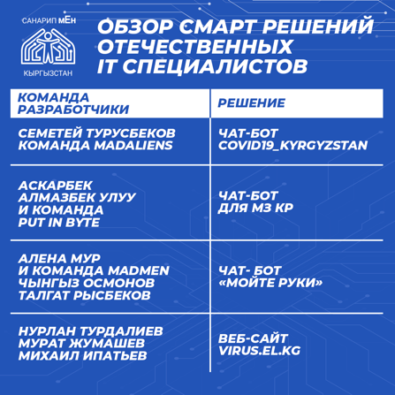 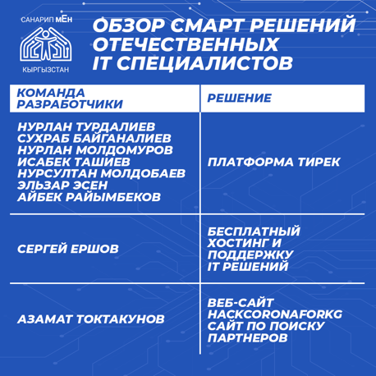 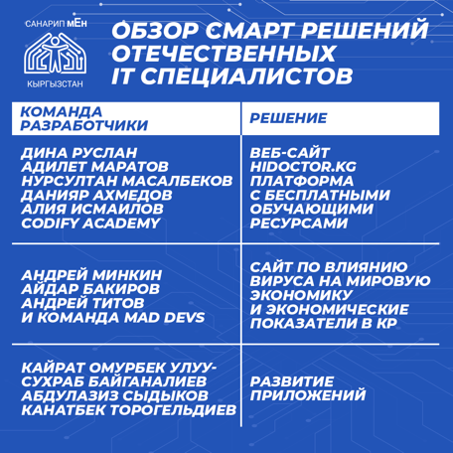 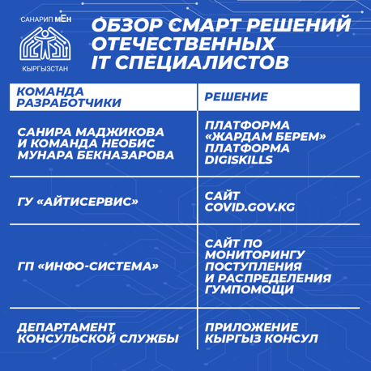 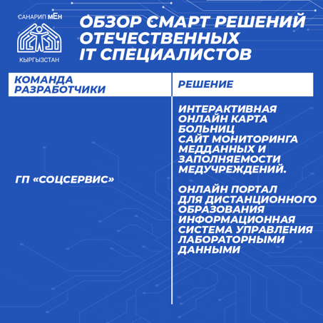 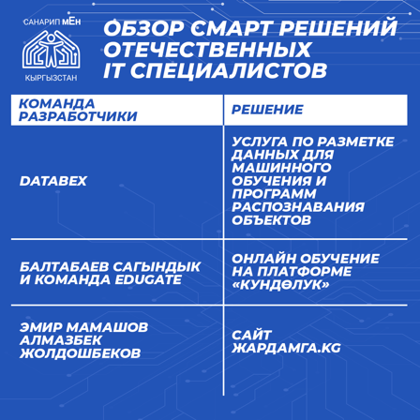 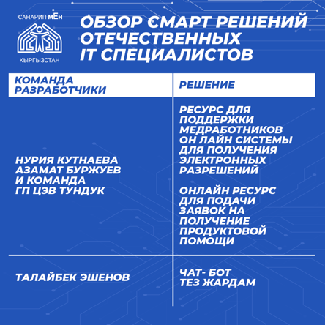 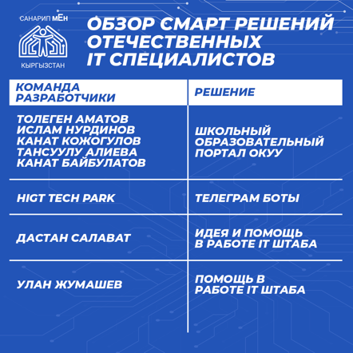 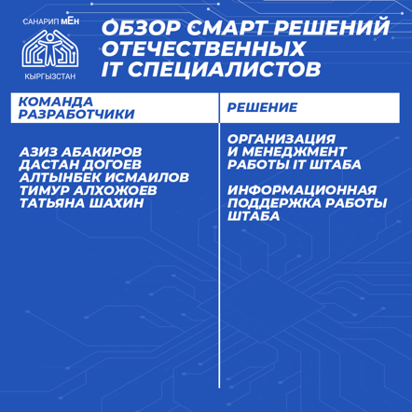

Report on the work performed on the implementation of the "Sanarip" project on the Kaktus.media subdomain
March 5, 2020.

№ | Name of service | number
1 | Subdomain development and introduction to the main page of Kaktus.media  https://kaktus.media/?lable=38668  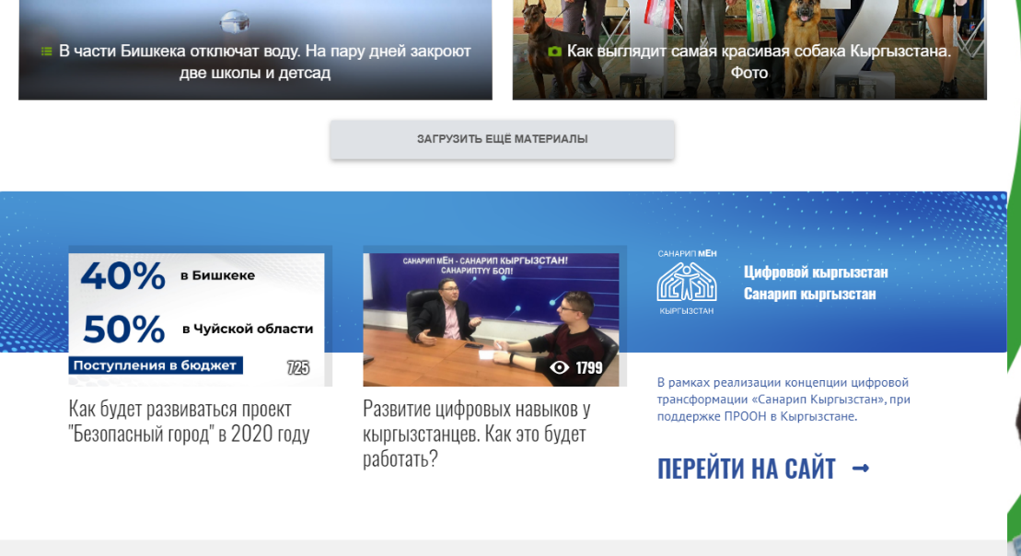 | 1
2 | Developing a template for Instagram posts  https://drive.google.com/open?id=1VukK4baKN0hZdUr9p3OhsyWZHx9qAU7L | 1
3 | Writing and posting articles  - 1. How the "Tunduk" system works - the foundation of digitalization in Kyrgyzstan - 1138 views  https://kaktus.media/doc/404920_kak_rabotaet_sistema_tyndyk_fyndament_cifrovizacii_v_kyrgyzstane.html  - 2. How the Safe City project will develop in 2020 - 941 views  https://kaktus.media/doc/406401_kak_bydet_razvivatsia_proekt_bezopasnyy_gorod_v_2020_gody.html  - Development of digital skills in Kyrgyzstanis. How will it work? - 2004 views  https://kaktus.media/doc/405965_razvitie_cifrovyh_navykov_y_kyrgyzstancev._kak_eto_bydet_rabotat.html  - 4. What to expect for Kyrgyzstanis from digital transformation in 2020 - 1898 views  https://kaktus.media/doc/405945_chto_jdat_kyrgyzstancam_ot_cifrovoy_transformacii_v_2020_gody.html  - 5. Dastan Dogoev on digital transformation in Kyrgyzstan. Video interview - 1933 views  https://kaktus.media/doc/405492_dastan_dogoev_o_cifrovoy_transformacii_v_kyrgyzstane._videointervu.html  - 6. What is "Sanarip Kyrgyzstan". Infographics - 1,027 views  https://kaktus.media/doc/405484_chto_takoe_sanarip_kyrgyzstan._infografika.html  - 7. "Electronic enrollment in school". How to get to first grade and what has changed this year - 556 views  https://kaktus.media/doc/404525_elektronnaia_zapis_v_shkoly._kak_popast_v_pervyy_klass_i_chto_izmenilos_v_etom_gody.html  - " Electronic queue for kindergarten ". What has changed in the system and how to register - 375 views  https://kaktus.media/doc/404531_elektronnaia_ochered_v_detskiy_sad._chto_izmenilos_v_sisteme_i_kak_zaregistrirovatsia.html  - 9. "Electronic appointment with a doctor". How to enroll and what will change in 2020 (video) - 940 views  https://kaktus.media/doc/404545_elektronnaia_zapis_k_vrachy._kak_zapisatsia_i_chto_izmenitsia_v_2020_gody_video.html  - 10. Export of services, mobile games and blockchain. How Belarus Hi Tech Park works - 836 views  https://kaktus.media/doc/405495_eksport_yslyg_mobilnye_igry_i_blokcheyn._kak_rabotaet_park_vysokih_tehnologiy.html  - 11. How digital transformation affects Kyrgyz legislation - 681 views  https://kaktus.media/doc/406967_kak_cifrovaia_transformaciia_vliiaet_na_zakonodatelstvo_kyrgyzstana.html  - 12. Review of "E-Kyzmat" - a unified database of civil servants of Kyrgyzstan - 1707 views  https://kaktus.media/doc/406711_obzor_e_kyzmat_edinoy_bazy_dannyh_o_gosslyjashih_kyrgyzstana.html  - How to digital  https://kaktus.media/doc/406715_kyrgyzstandyktardyn_sanarip_jondomyn_onyktyryy_joldory.html  - About Digital KG  https://bilesinbi.kg/article/4863_Kyrgyzstandyktardyn_sanarip_jondomyn_onyktyryy_joldory/  - 15. How to get a patent for doing business without leaving your home. Manual - 612 views  https://kaktus.media/doc/407266_kak_polychit_patent_na_vedenie_biznesa_ne_vyhodia_iz_doma._instrykciia.html  - 16. Philosophy of digital nomads and human-centered approach to digitalization. What is it? - 109 views  https://kaktus.media/doc/407342_filosofiia_cifrovyh_kochevnikov_i_chelovekocentrichnyy_podhod_cifrovizacii._chto_eto.html | 16
4 | Facebook  facebook.com/kaktus.kyrgyzstan/posts/2755101444566835?__tn__=-R  facebook.com/kaktus.kyrgyzstan/posts/2755417207868592?__tn__=-R  facebook.com/kaktus.kyrgyzstan/posts/2758129014264078?__tn__=-R  facebook.com/kaktus.kyrgyzstan/posts/2758130854263894?__tn__=-R  facebook.com/kaktus.kyrgyzstan/posts/2758132684263711?__tn__=-R  facebook.com/kaktus.kyrgyzstan/posts/2758141657596147?__tn__=-R  facebook.com/kaktus.kyrgyzstan/posts/2758151624261817?__tn__=-R  facebook.com/kaktus.kyrgyzstan/posts/2758154850928161?__tn__=-R  facebook.com/kaktus.kyrgyzstan/posts/2758126200931026?__tn__=-R  facebook.com/kaktus.kyrgyzstan/posts/2758122297598083?__tn__=-R  facebook.com/kaktus.kyrgyzstan/posts/2769767186433594?__tn__=-R  facebook.com/kaktus.kyrgyzstan/posts/2782015138542132?__tn__=-R  facebook.com/kaktus.kyrgyzstan/posts/2782377918505854?__tn__=-R | 13
5 | Instagram  https://www.instagram.com/p/B88i_BJgNcb/  https://www.instagram.com/p/B88M0j0IgqK/  https://www.instagram.com/p/B88CEtJCW1g/  https://www.instagram.com/p/B87vB23o1Tj/  https://www.instagram.com/p/B86lK1pIz9M/  https://www.instagram.com/p/B8_Su2VIplO/  https://www.instagram.com/p/B8_DQC6Id-7/  https://www.instagram.com/p/B8-jLrLiF_-/  https://www.instagram.com/p/B89TiKLo5Mv/  https://www.instagram.com/p/B88_0CzIcoF/  https://www.instagram.com/p/B88wImfKTF1/  https://www.instagram.com/p/B9G9Ka4ouxG/  https://www.instagram.com/tv/B9VzGFkqOPa/  https://www.instagram.com/p/B9WSaf-osA-/ | 14
6 | Instagram Stories  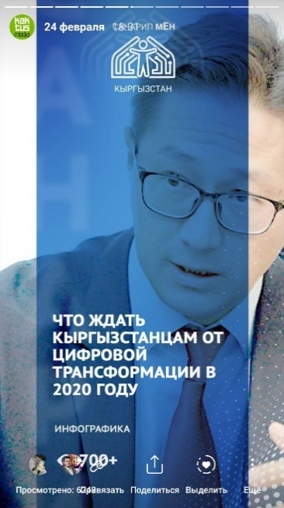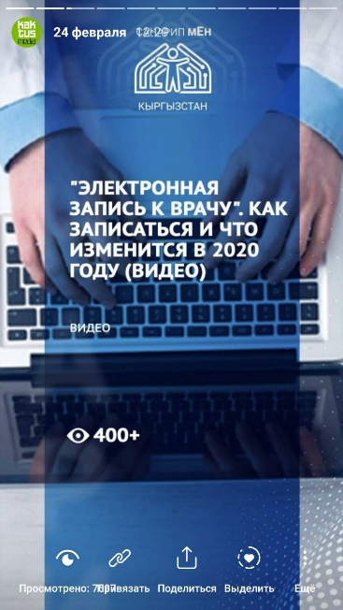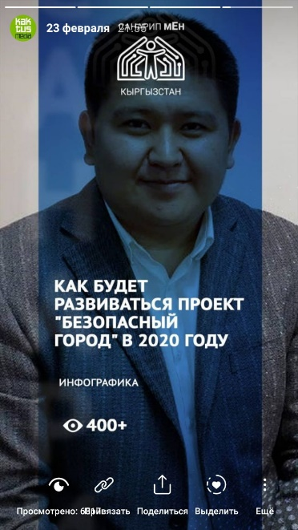 | 12
 | 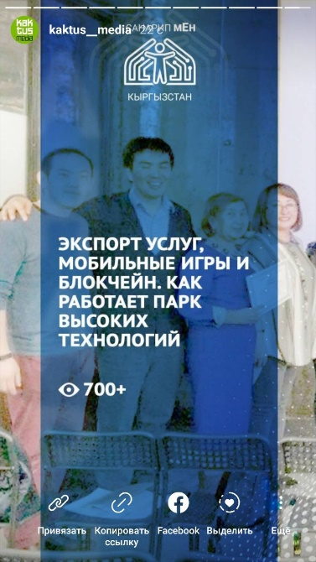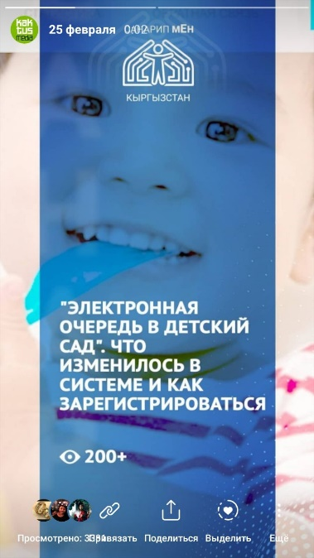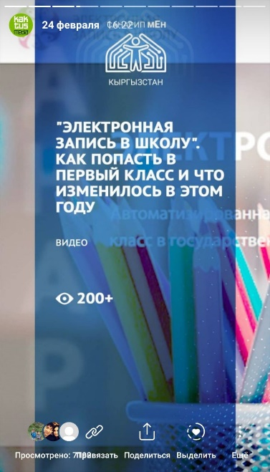
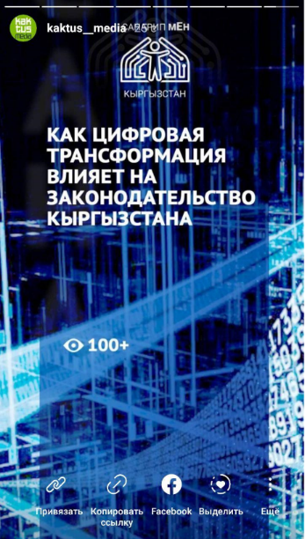
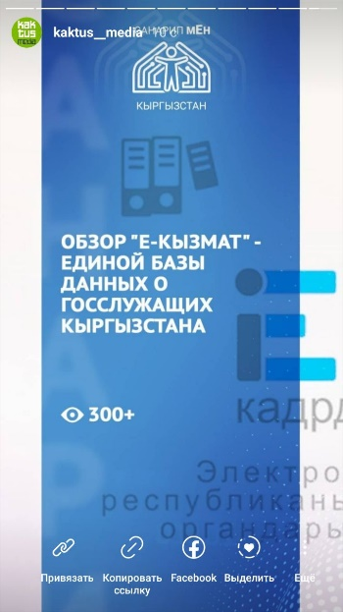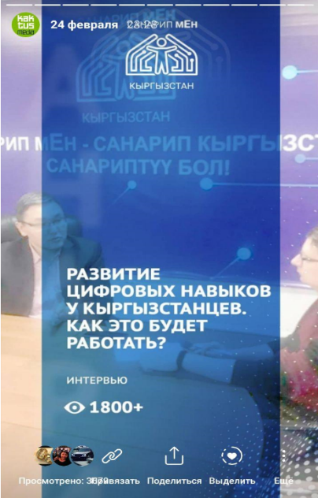
☐ 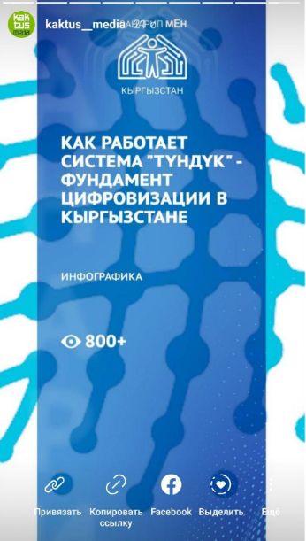
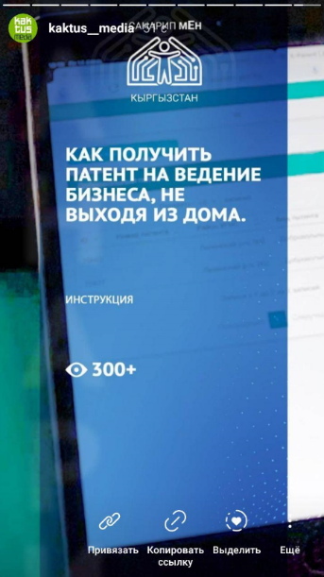
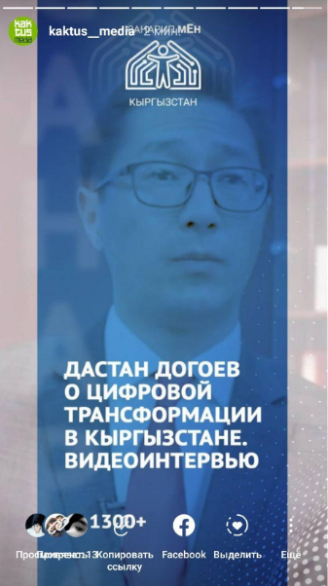

 | 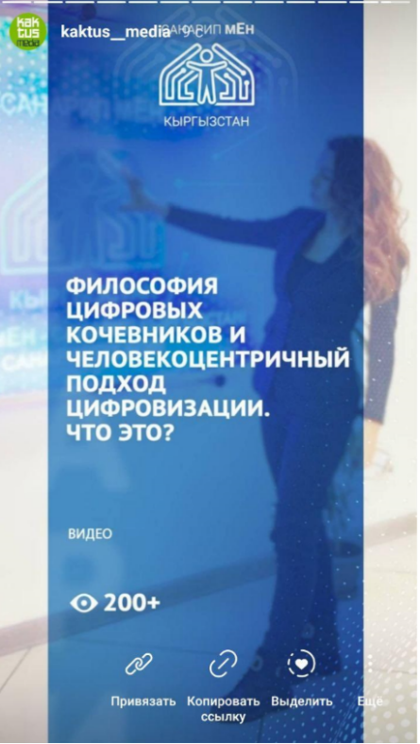
 | Total | 70

- FINANCIAL MANAGEMENT
Output | Budgeted for the reported year | Delivered for the reported year | Delivery rate for the reported year (%) | Budgeted for the entire project | Delivered since the project start
Activity 1. Improved digital skills development in the system of formal education
Activity 2. Established ITHubOsh in Osh City for young entrepreneurs and application of new learning models in non-formal educational settings
Activity 3 Project Management (salaries)
Activity 4 Administrative costs
GMS
Total

*With commitments
*Comments: 2020 figures are not final and subject to change, as FY2020 is not yet closed officially in Atlas.

Submitted by __Kanagat Alyshbaev, Project coordinator Digital skills and opportunities for youth employment towards digital economy in the Kyrgyz Republic

Date__35.12.2020

